

Dichloromethylation of Nitrobenzene Derivatives via Vicarious Nucleophilic Substitution of Hydrogen with Trichloromethyl Carbanions in Flow –
Supplementary Information

A thesis submitted for the degree of
MASTER OF SCIENCE

By

George Lyall-Brookes

26/07/2024

Contents

4-chloro-2-(dichloromethyl)-1-nitrobenzene (82) 3
4-bromo-2-(dichloromethyl)-1-nitrobenzene (118) 6
2-(dichloromethyl)-4-iodo-1-nitrobenzene (120) 9
2-(dichloromethyl)-4-fluoro-1-nitrobenzene (119) 12
2-(dichloromethyl)-1-nitro-4-(trifluoromethyl)benzene (121) 14
2-(dichloromethyl)-1,4-dinitrobenzene (122) 16
1-(dichloromethyl)-2-nitrobenzene (116), 1-(dichloromethyl)-4-nitrobenzene (117) 19

4-chloro-2-(dichloromethyl)-1-nitrobenzene (82)
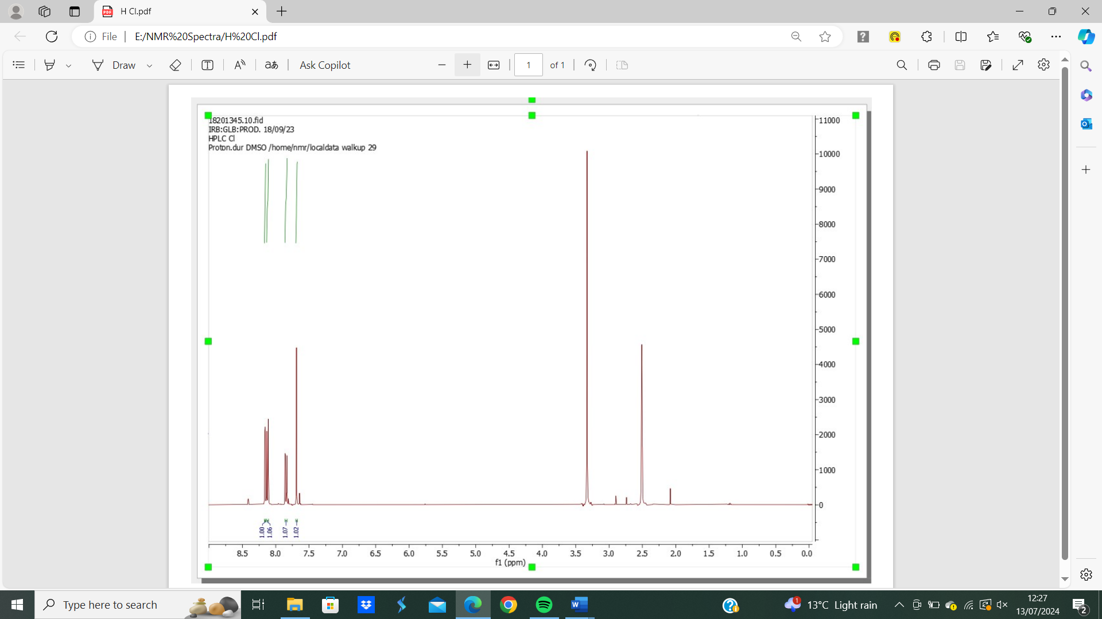
Figure 1: 4-chloro-2-(dichloromethyl)-1-nitrobenzene (82) ¹H NMR spectrum.

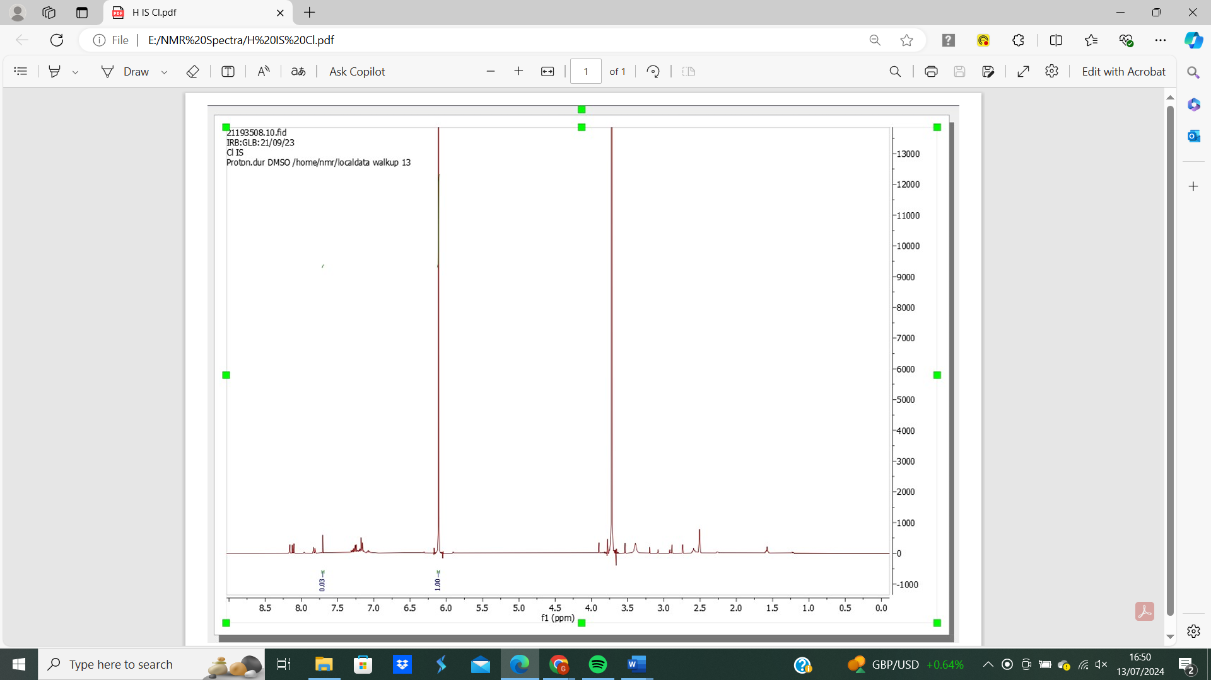
Figure 2: 4-chloro-2-(dichloromethyl)-1-nitrobenzene (82) ¹H NMR spectrum with internal standard 10-minute run time.

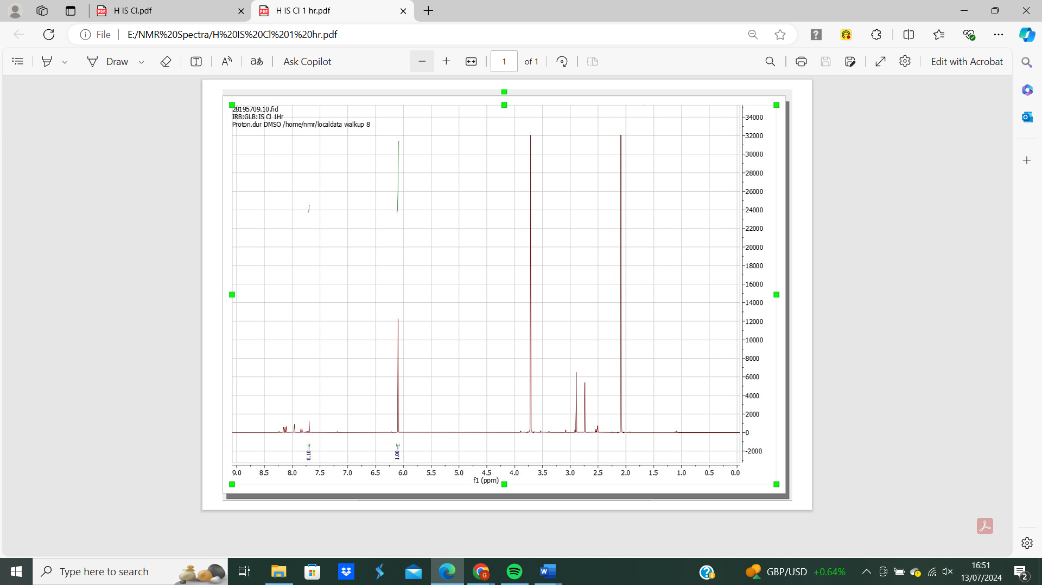
Figure 3: 4-chloro-2-(dichloromethyl)-1-nitrobenzene (82) ¹H NMR spectrum with internal standard 60-minute run time.
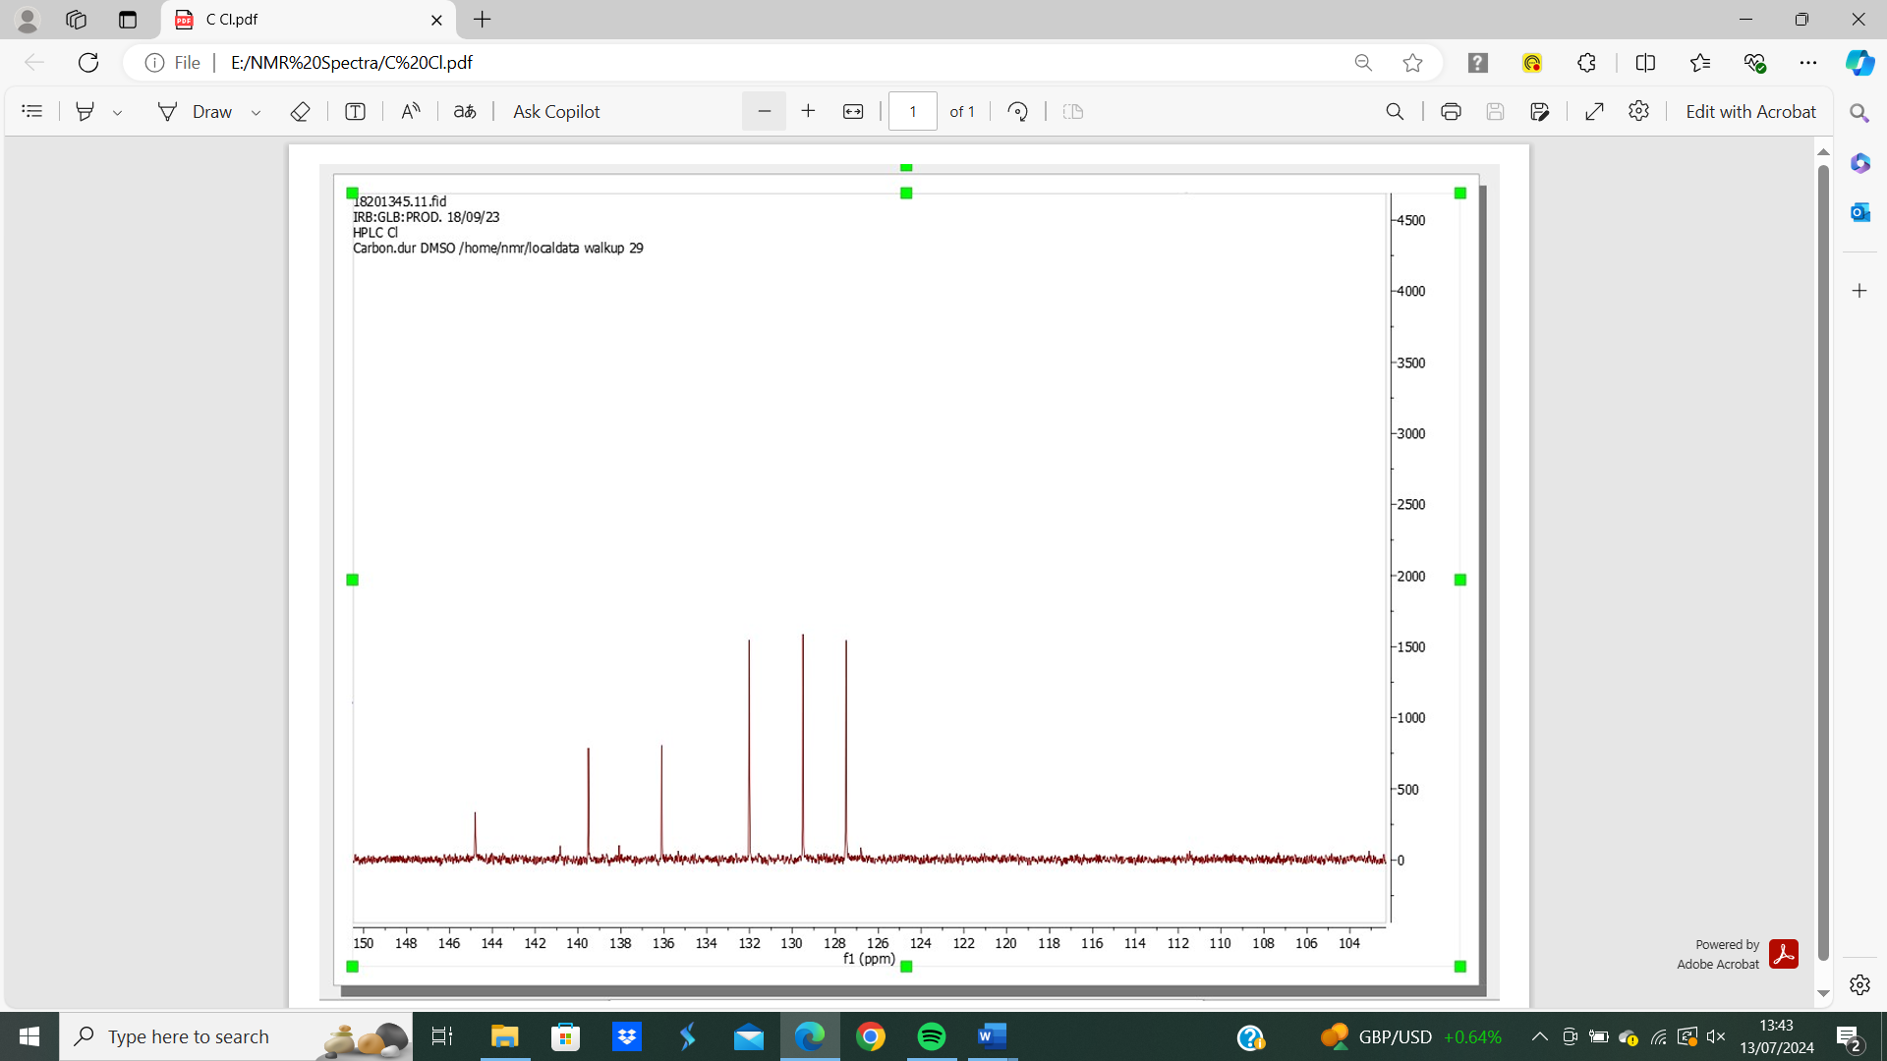
Figure 4: 4-chloro-2-(dichloromethyl)-1-nitrobenzene (82) ¹³C NMR Spectrum.
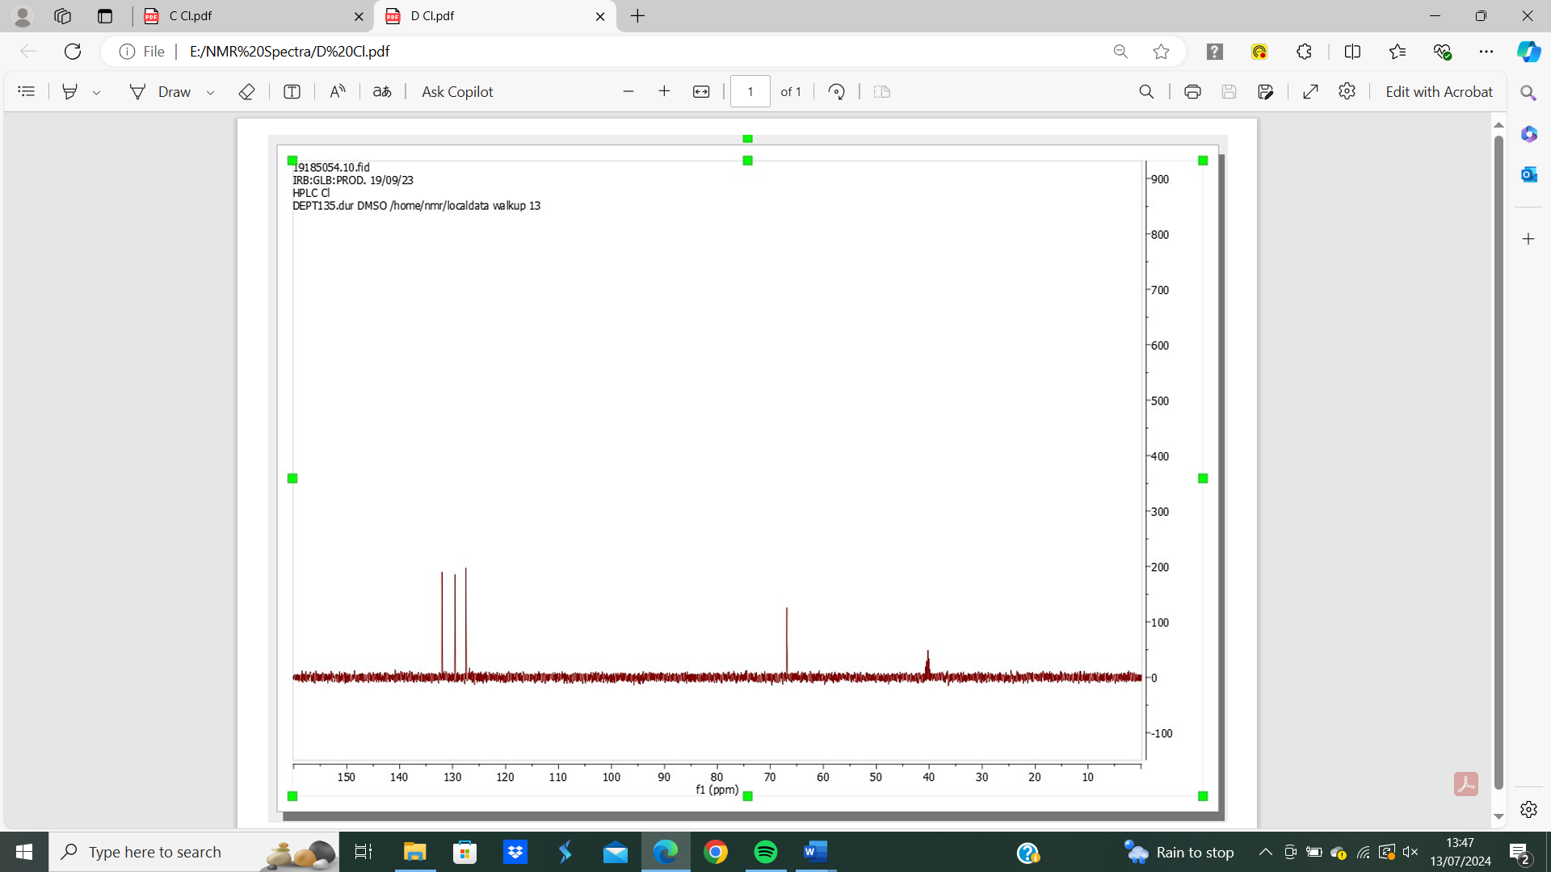
Figure 5: 4-chloro-2-(dichloromethyl)-1-nitrobenzene (82) ¹³C DEPT spectrum.

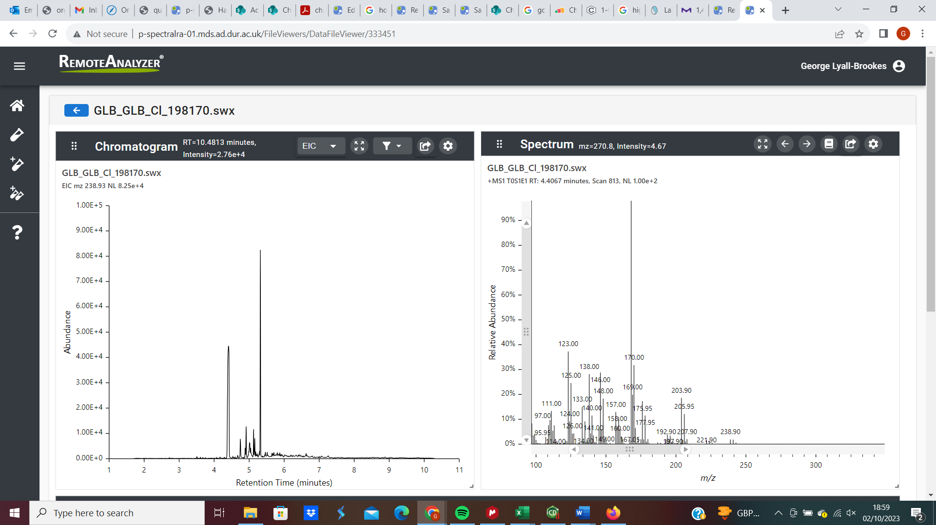
Figure 6: 4-chloro-2-(dichloromethyl)-1-nitrobenzene (82) GC-MS analysis.
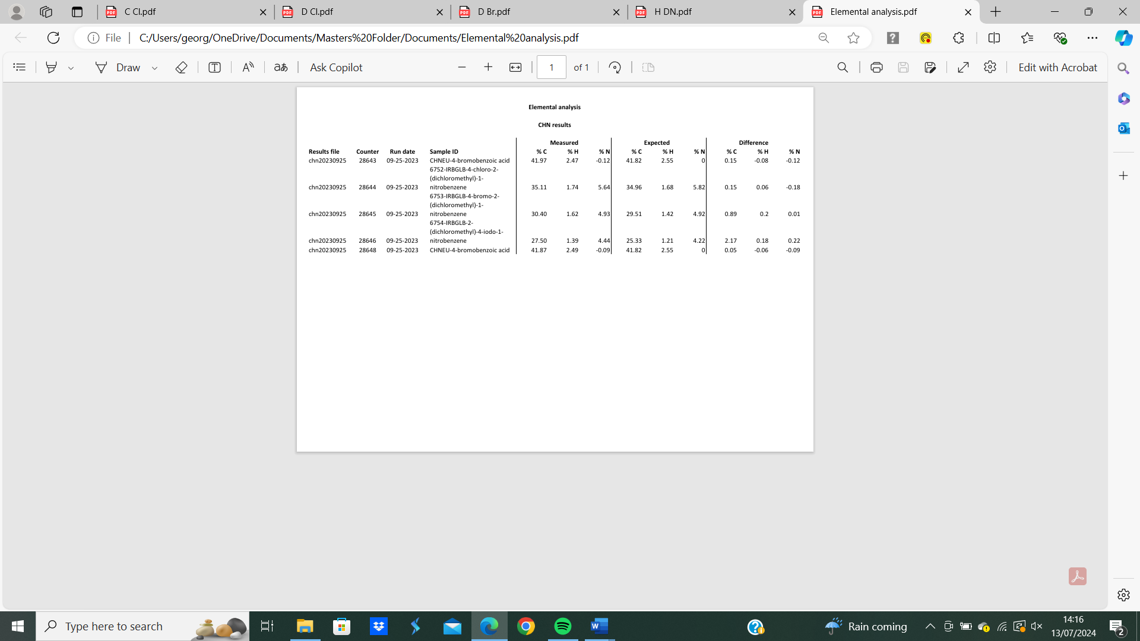
Figure 7: 4-chloro-2-(dichloromethyl)-1-nitrobenzene (82) elemental analysis.
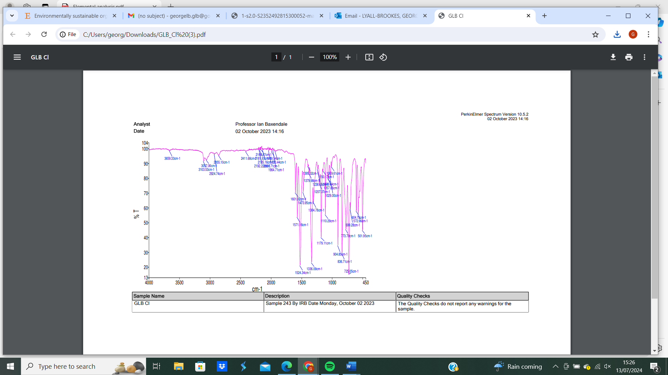
Figure 8: 4-chloro-2-(dichloromethyl)-1-nitrobenzene (82) IR spectrum

4-bromo-2-(dichloromethyl)-1-nitrobenzene (118)
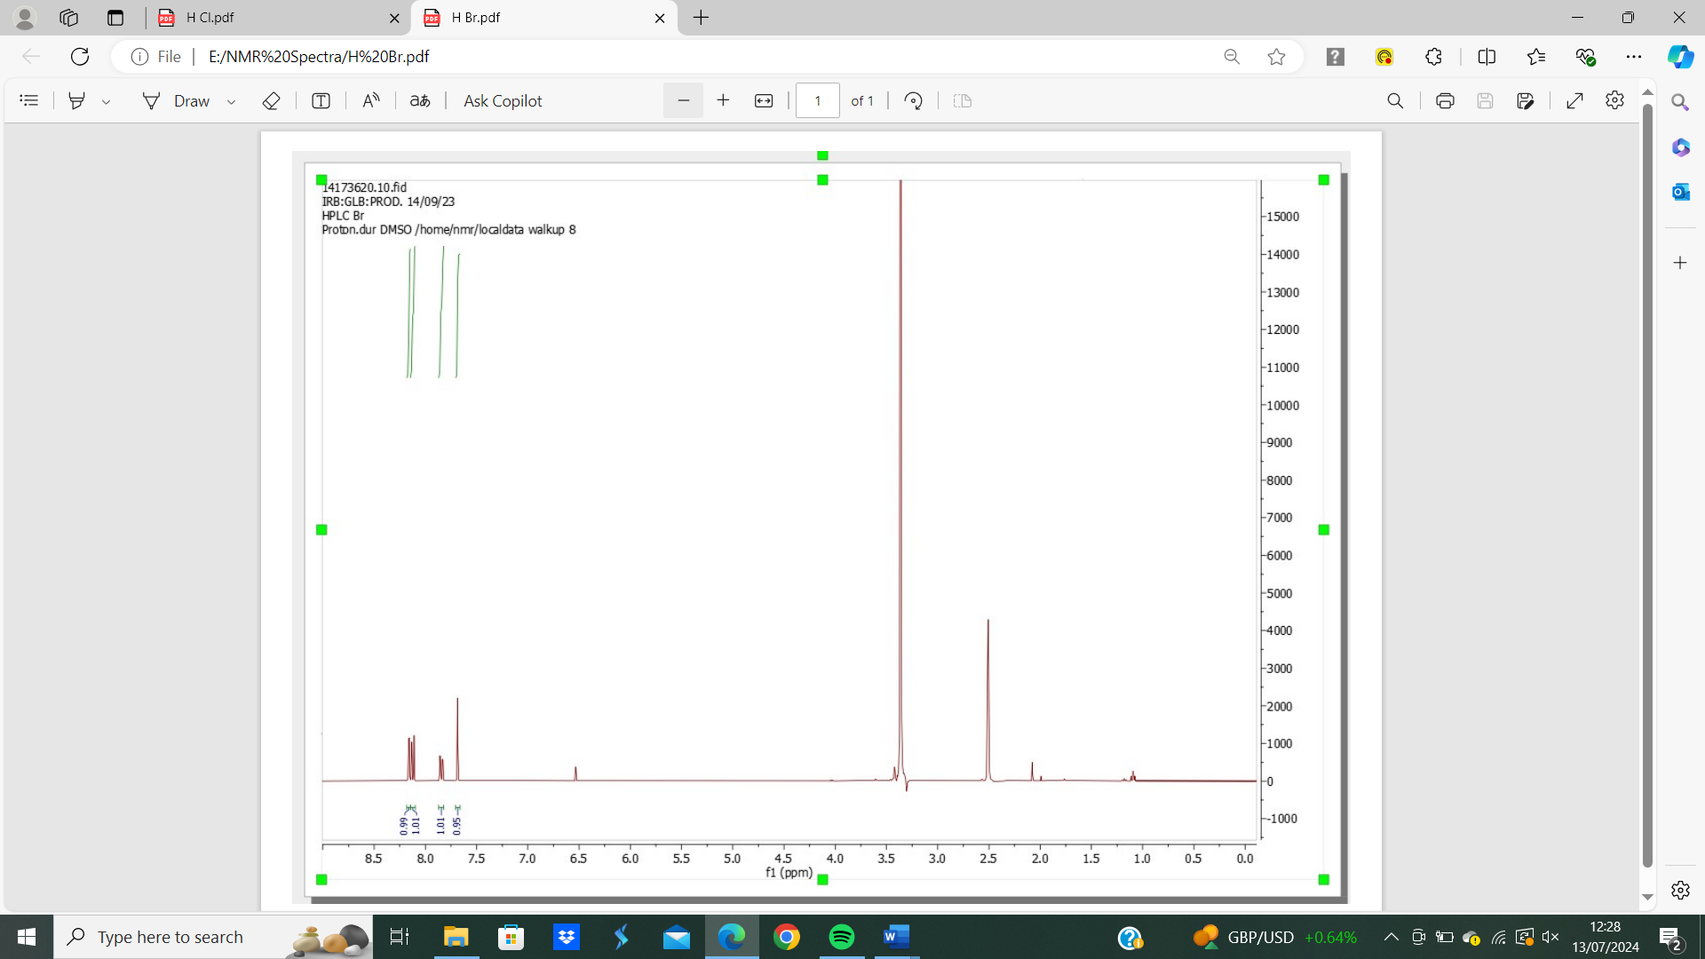
Figure 9: 4-bromo-2-(dichloromethyl)-1-nitrobenzene (118) 1H NMR spectrum.
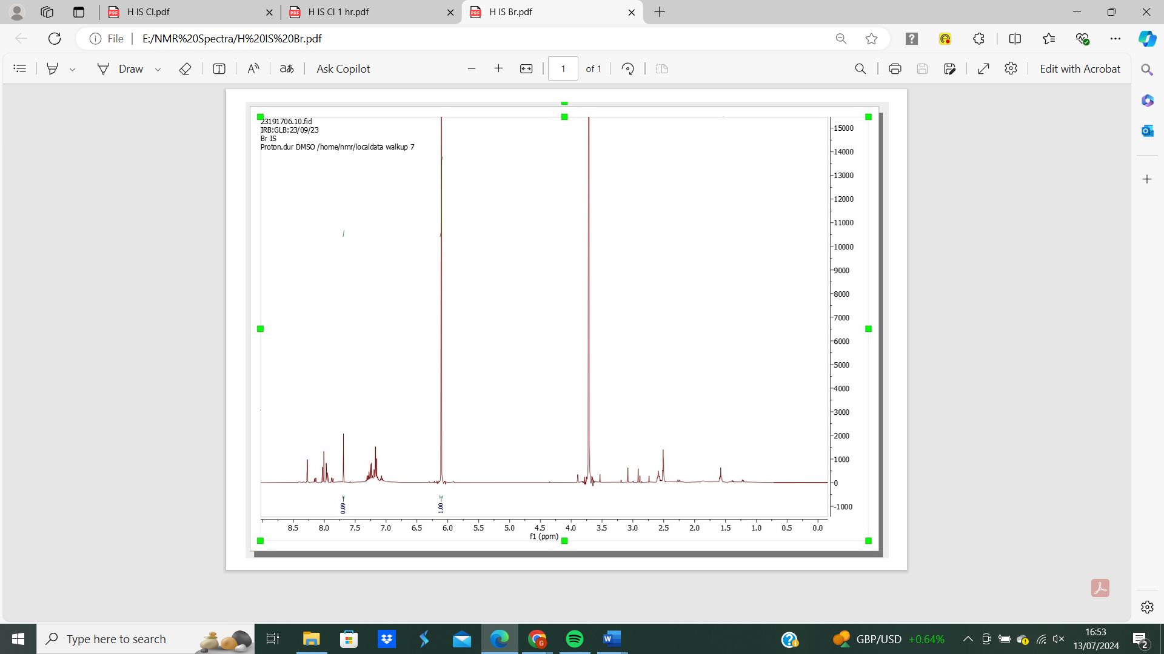
Figure 10: 4-bromo-2-(dichloromethyl)-1-nitrobenzene (118) 1H NMR spectrum with internal standard.
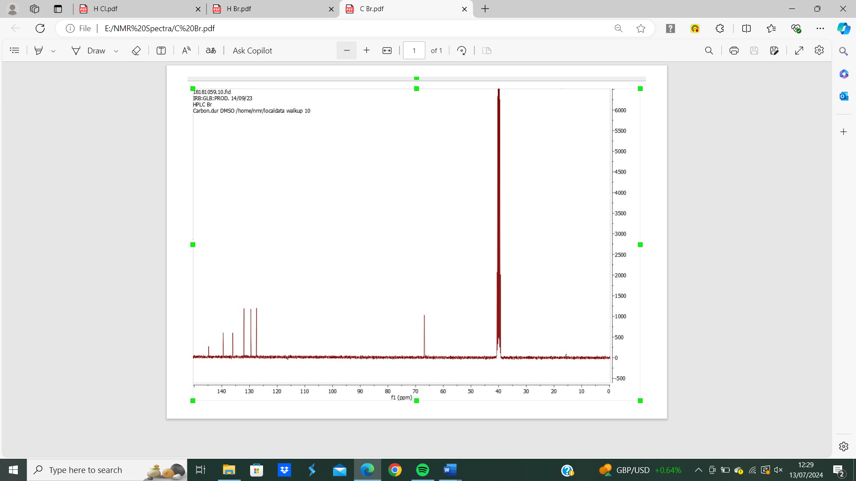
Figure 11: 4-bromo-2-(dichloromethyl)-1-nitrobenzene (118) ¹³C NMR spectrum.

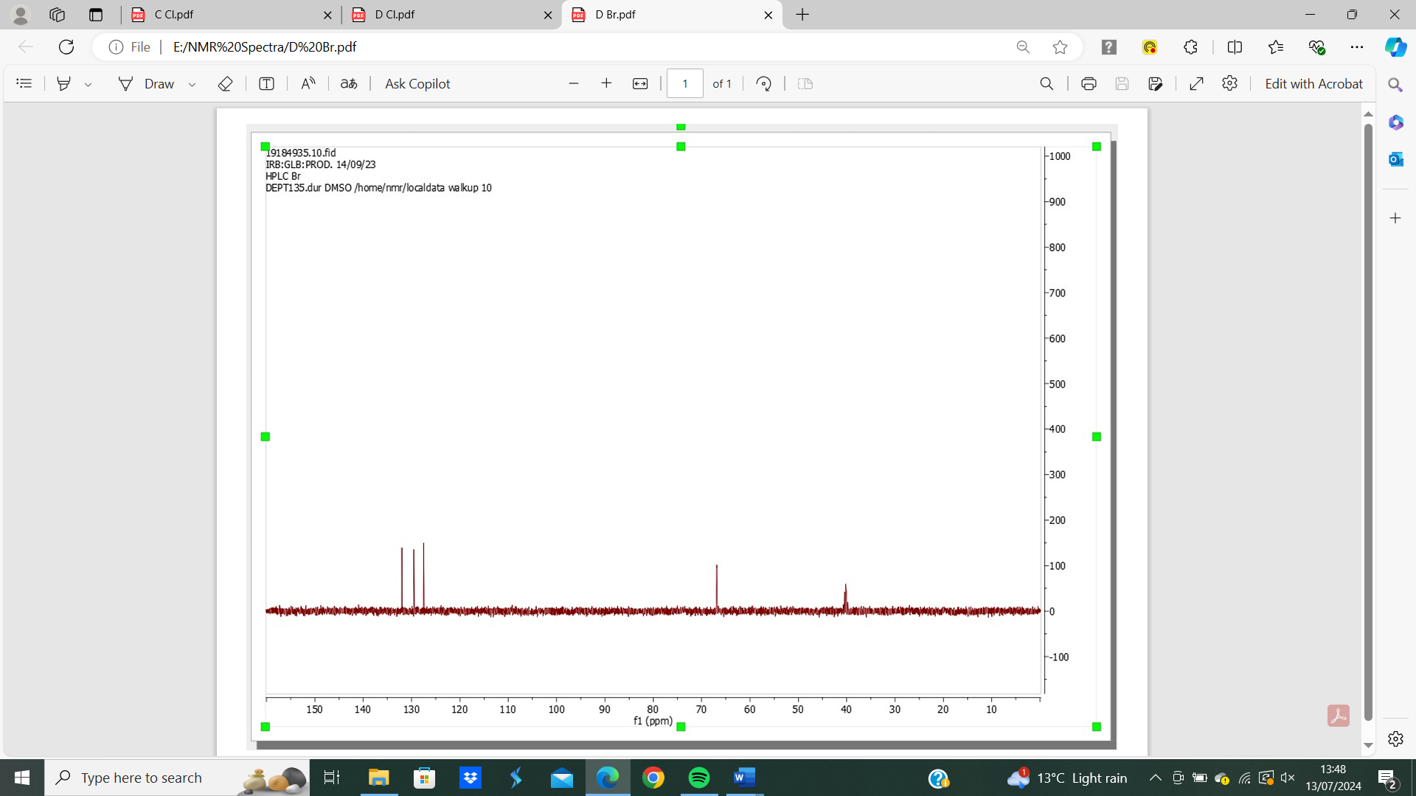
Figure 12: 4-bromo-2-(dichloromethyl)-1-nitrobenzene (118) ¹³C DEPT spectrum.
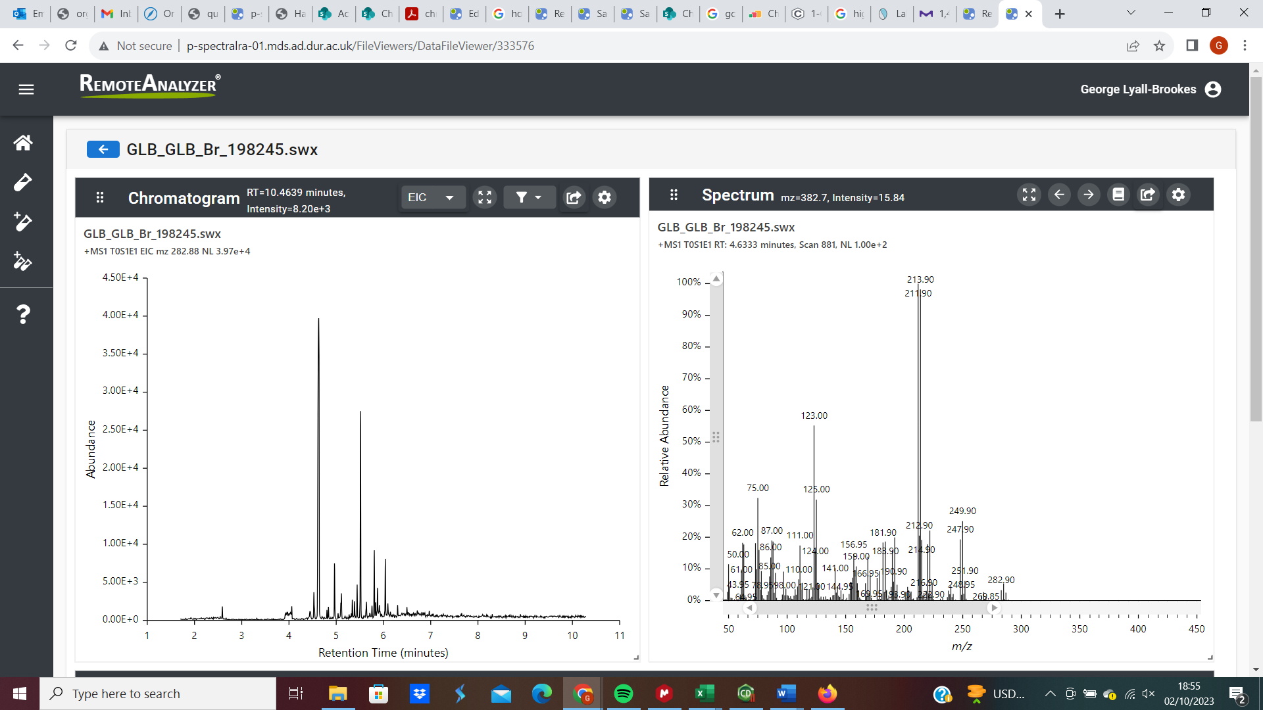
Figure 13: 4-bromo-2-(dichloromethyl)-1-nitrobenzene (118) GC-MS analysis.

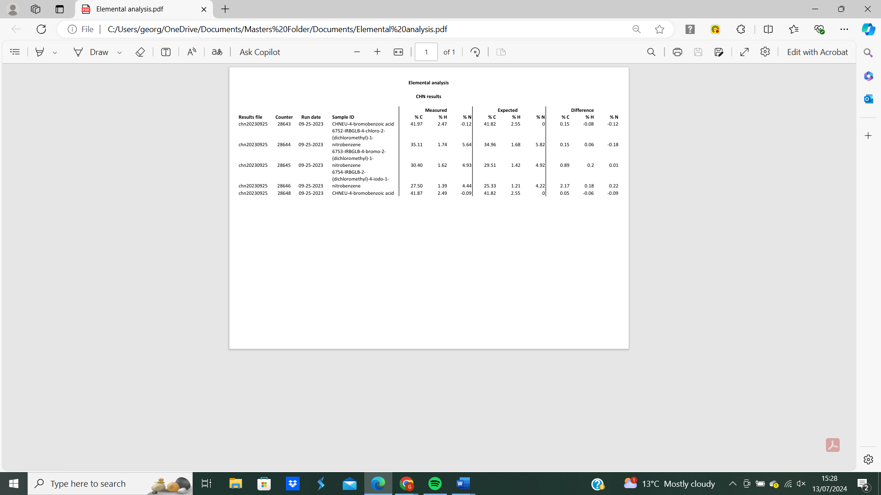
Figure 14: 4-bromo-2-(dichloromethyl)-1-nitrobenzene (118) elemental analysis.
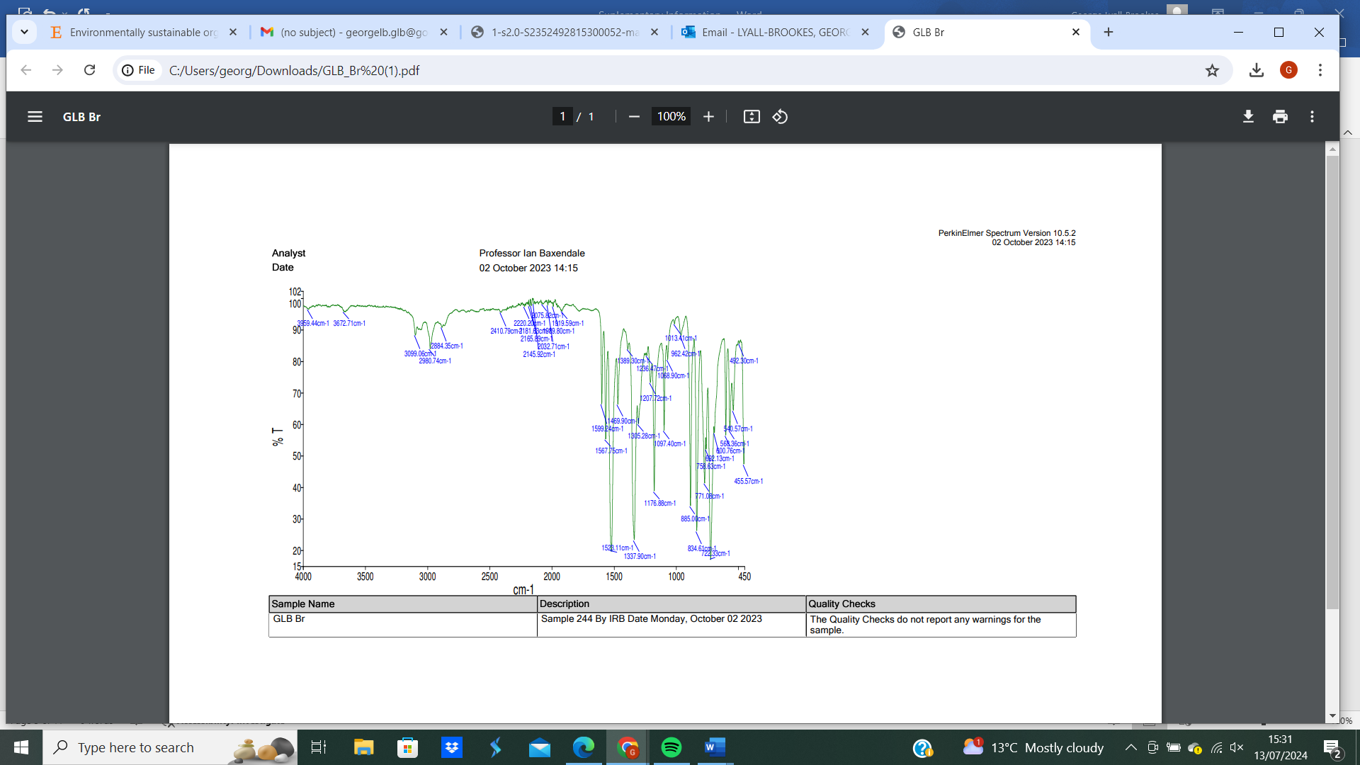
Figure 15: 4-bromo-2-(dichloromethyl)-1-nitrobenzene (118) 1H NMR spectrum.

2-(dichloromethyl)-4-iodo-1-nitrobenzene (120)
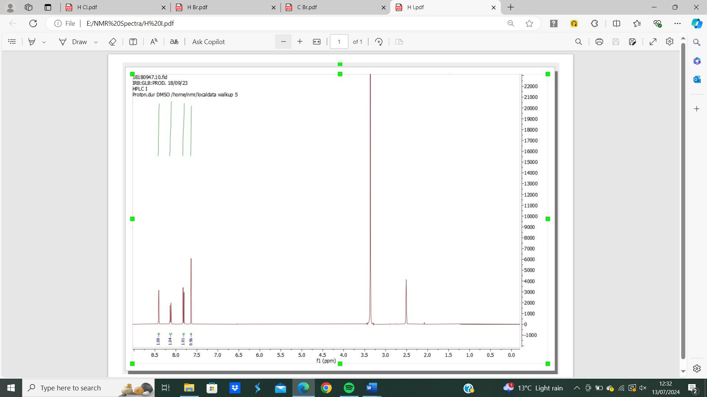

Figure 16: 2-(dichloromethyl)-4-iodo-1-nitrobenzene (120) ¹H NMR spectrum.

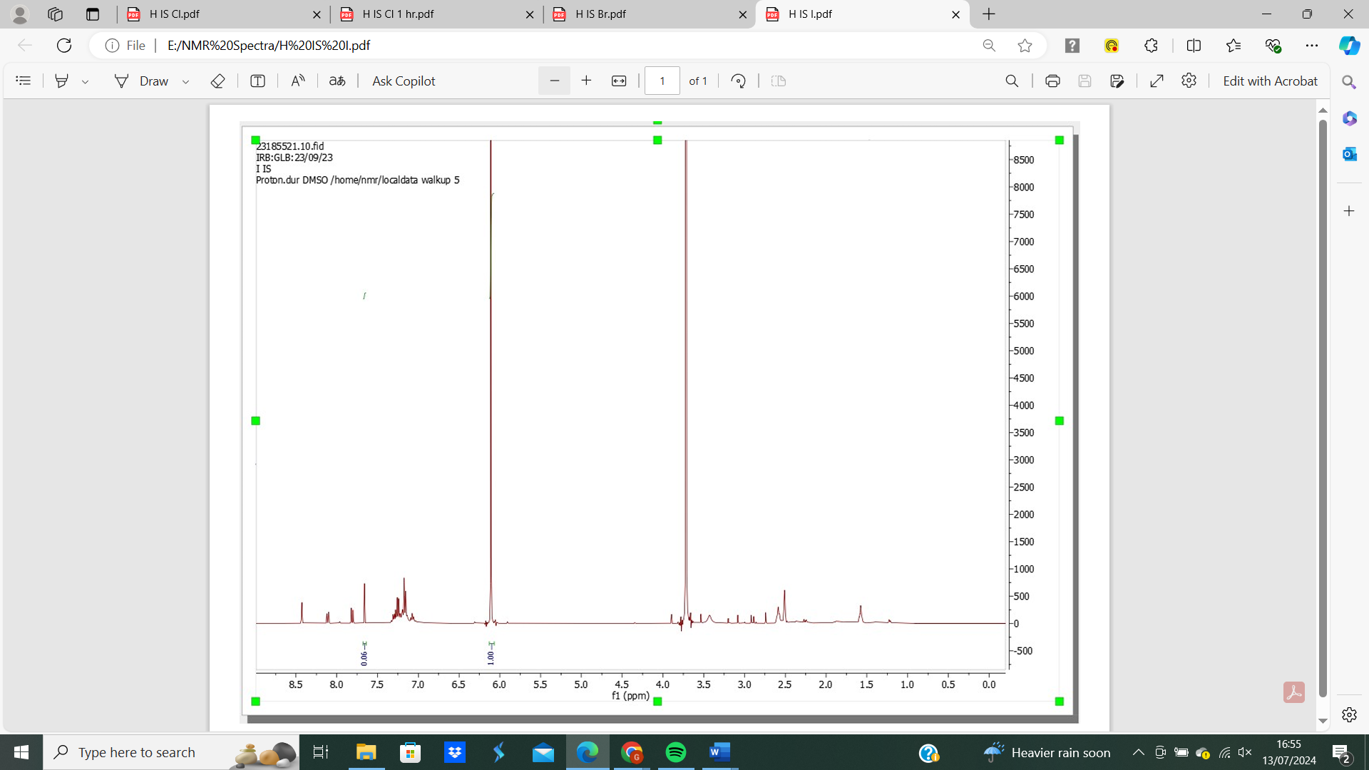

Figure 17: 2-(dichloromethyl)-4-iodo-1-nitrobenzene (120) ¹H NMR spectrum with internal standard.

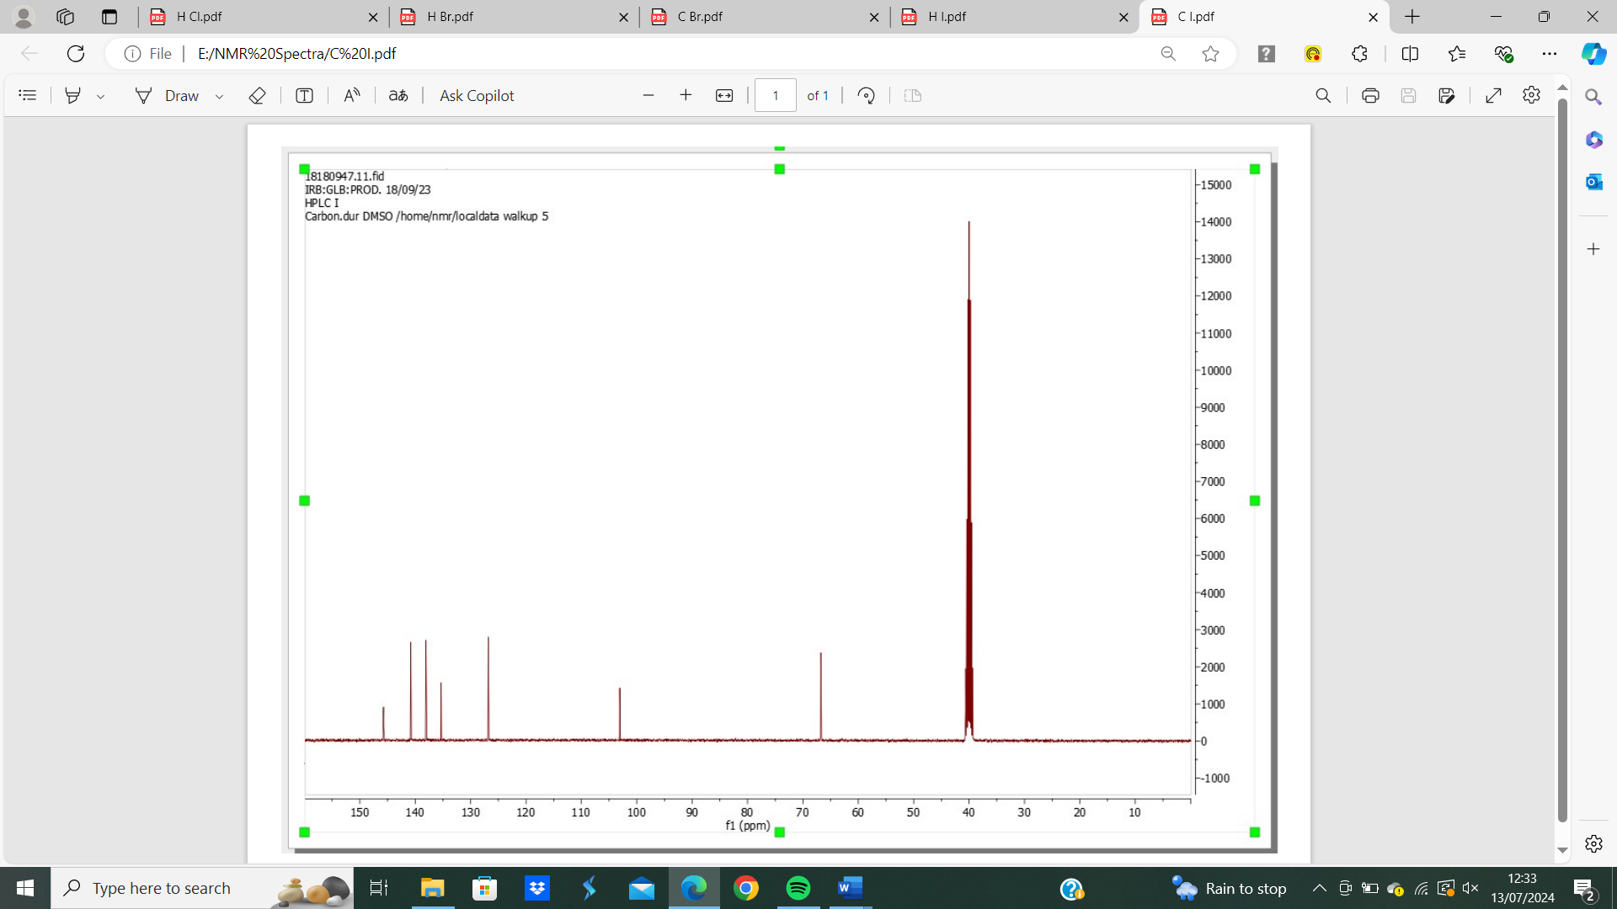

Figure 18: 2-(dichloromethyl)-4-iodo-1-nitrobenzene (120) ¹³C NMR spectrum.

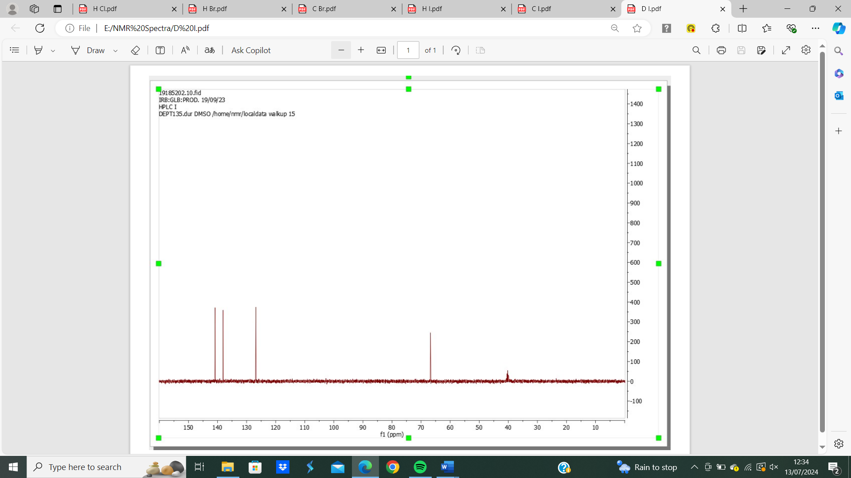

Figure 19: 2-(dichloromethyl)-4-iodo-1-nitrobenzene (120) ¹³C DEPT spectrum.
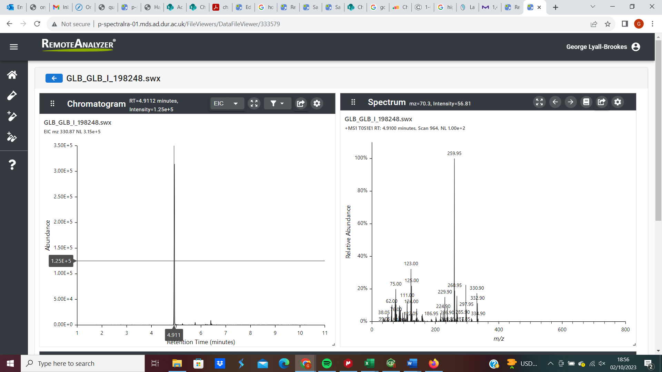

Figure 20: 2-(dichloromethyl)-4-iodo-1-nitrobenzene (120) GC-MS analysis.

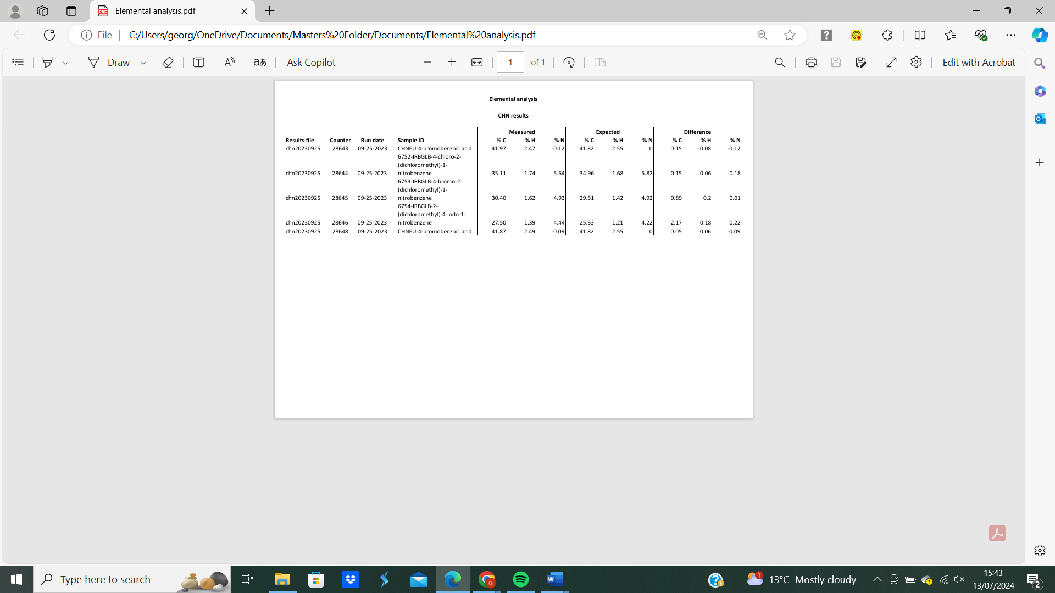

Figure 21: 2-(dichloromethyl)-4-iodo-1-nitrobenzene (120) elemental analysis.

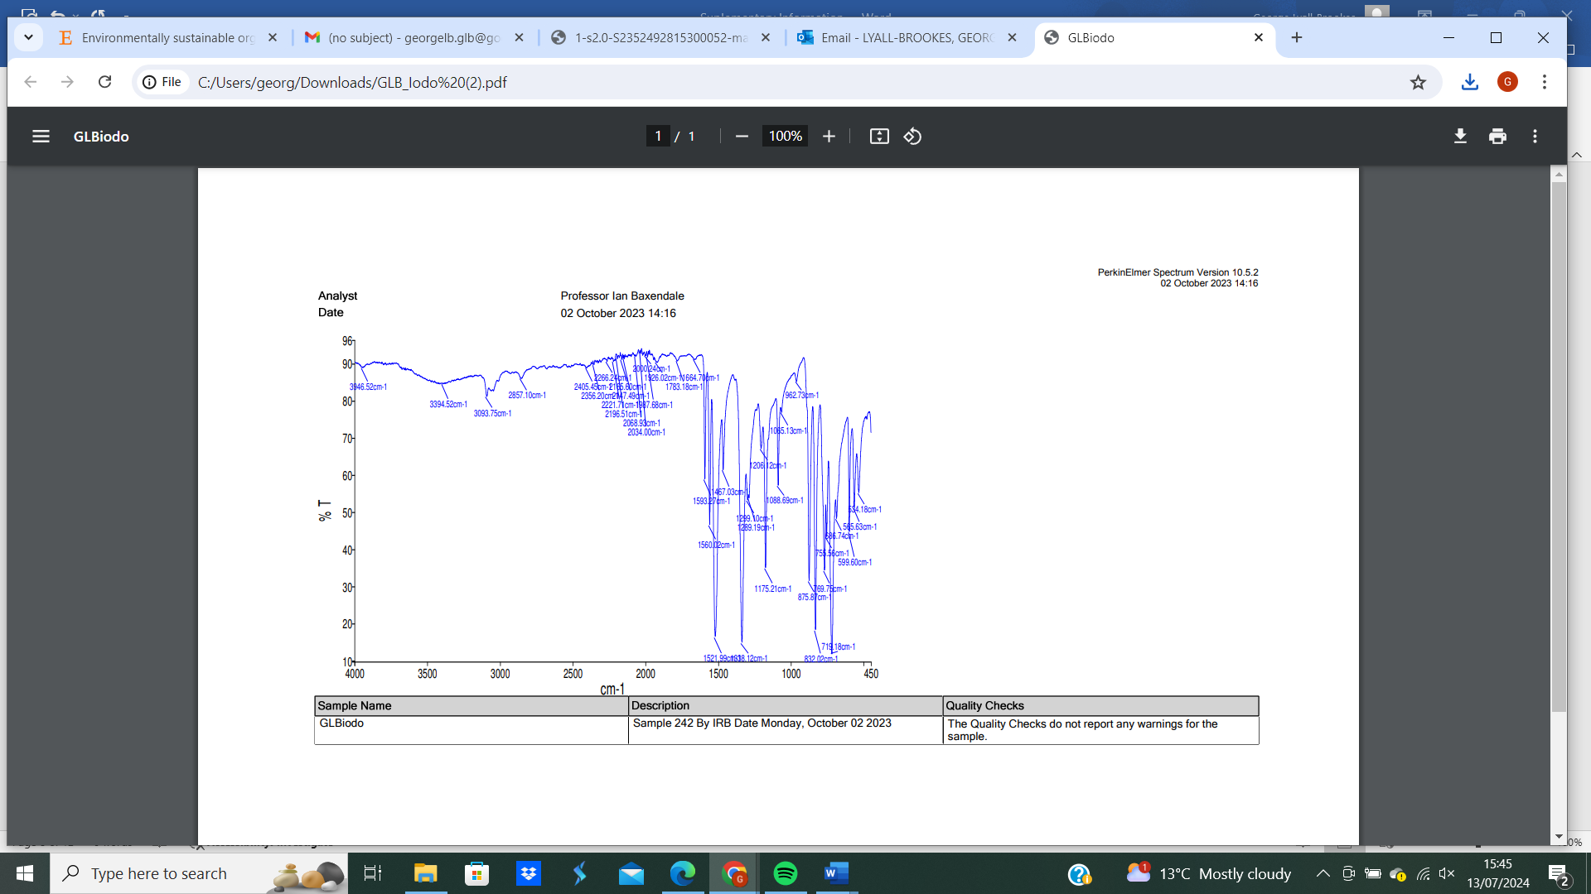

Figure 22: 2-(dichloromethyl)-4-iodo-1-nitrobenzene (120) IR analysis.

2-(dichloromethyl)-4-fluoro-1-nitrobenzene (119)
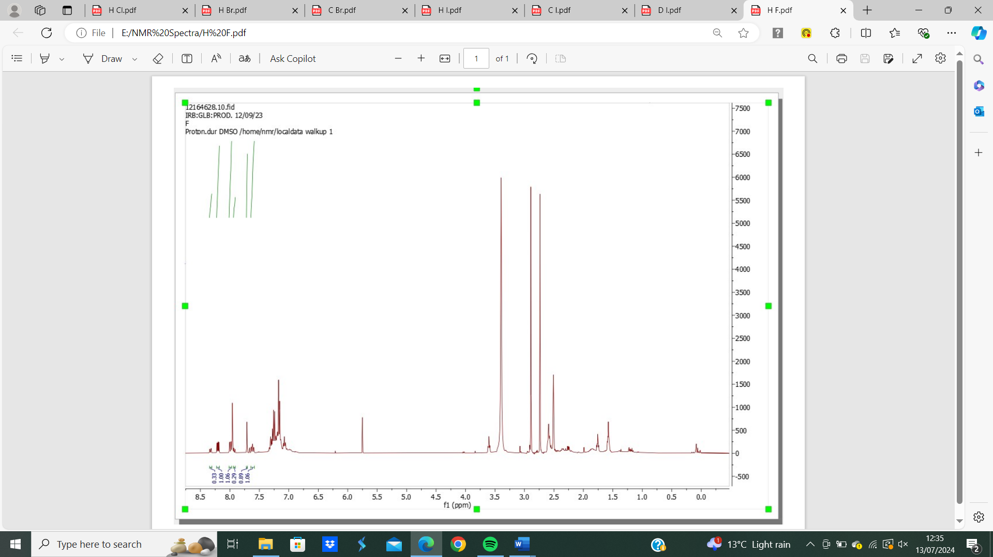
Figure 23: 2-(dichloromethyl)-4-fluoro-1-nitrobenzene (119) ¹H NMR spectrum.

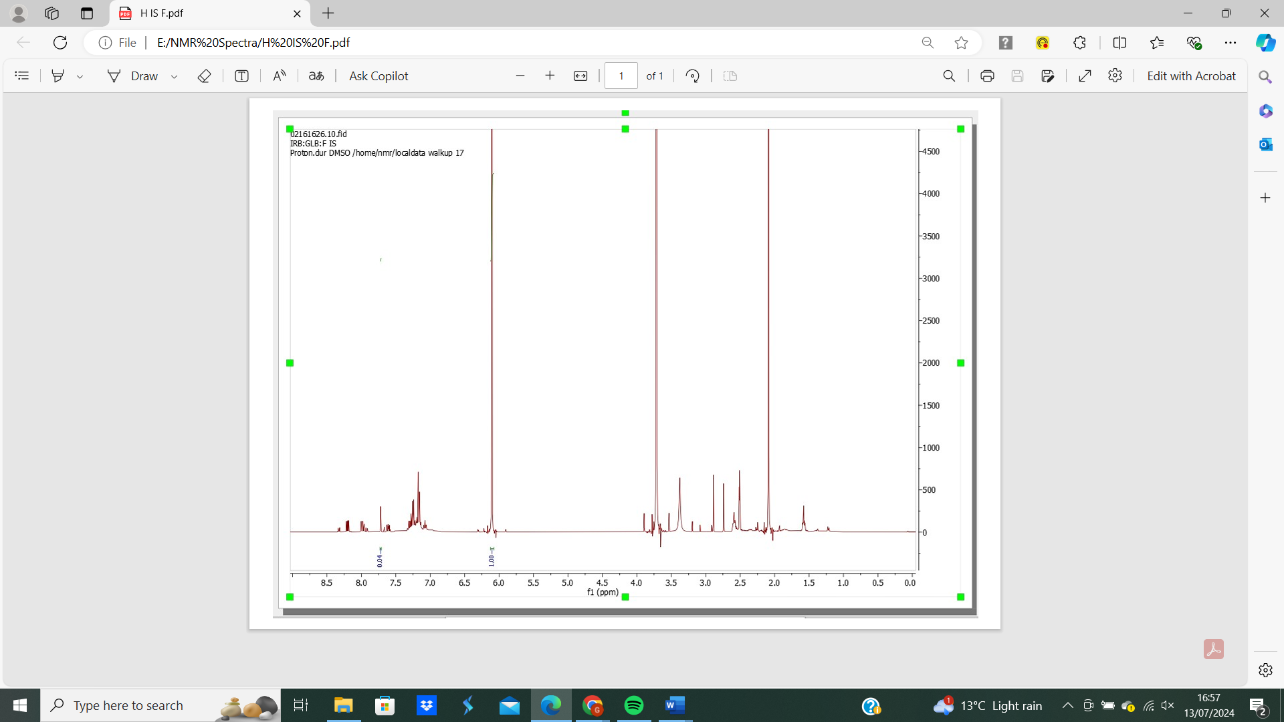
Figure 24: 2-(dichloromethyl)-4-fluoro-1-nitrobenzene (119) ¹H NMR spectrum with internal standard.

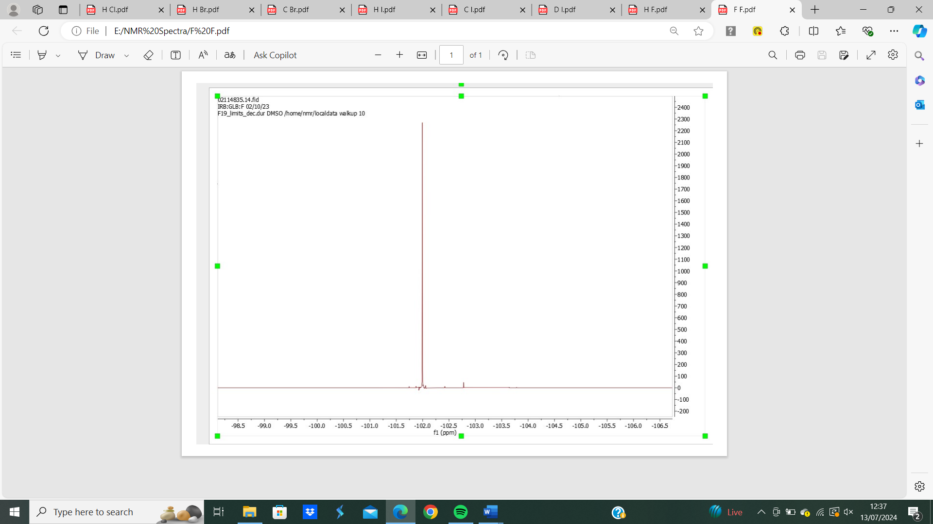
Figure 25: 2-(dichloromethyl)-4-fluoro-1-nitrobenzene (119) ¹⁹F NMR spectrum.

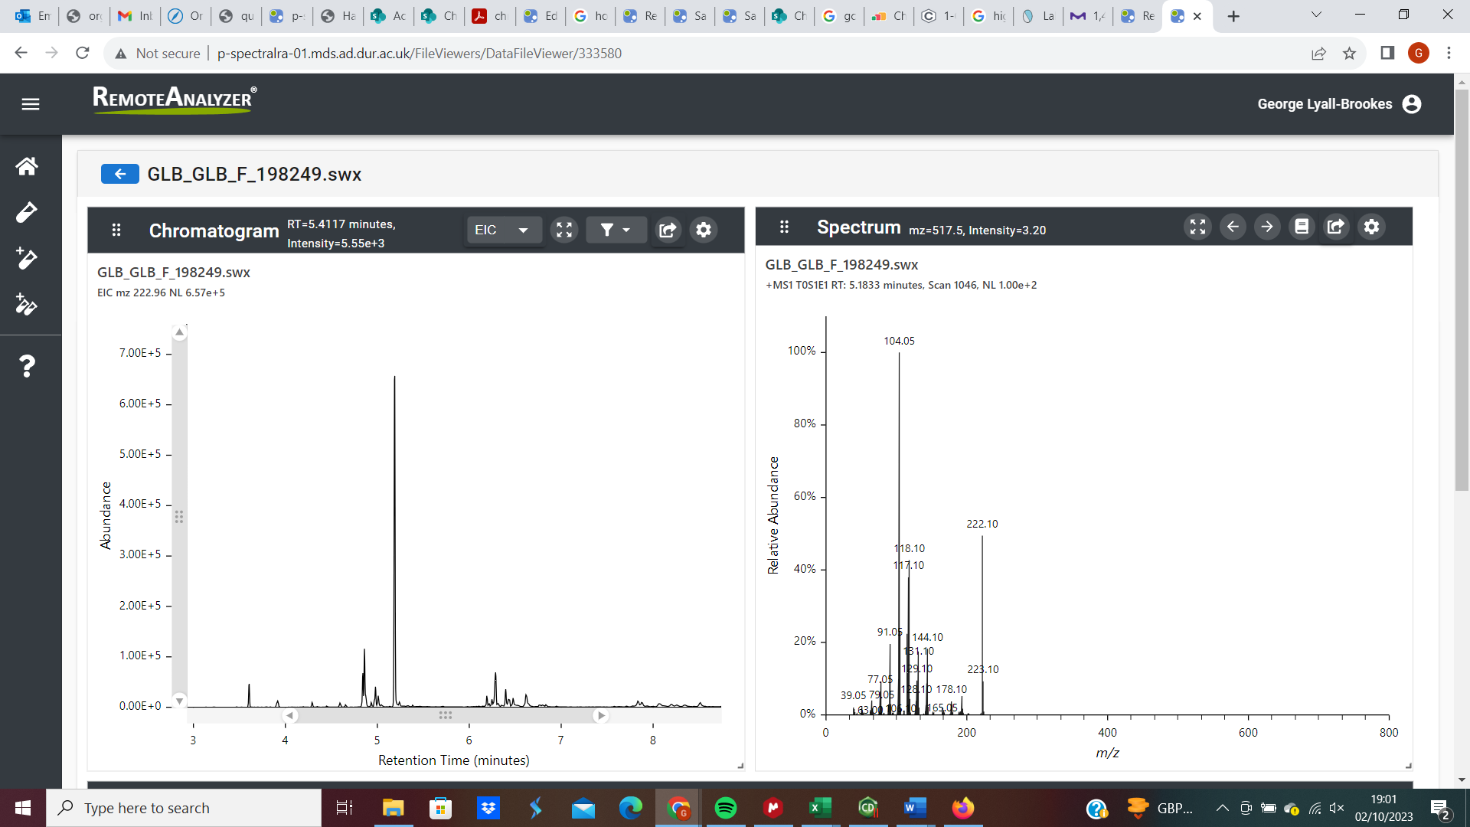
Figure 26: 2-(dichloromethyl)-4-fluoro-1-nitrobenzene (119) GC-MS analysis.

2-(dichloromethyl)-1-nitro-4-(trifluoromethyl)benzene (121)
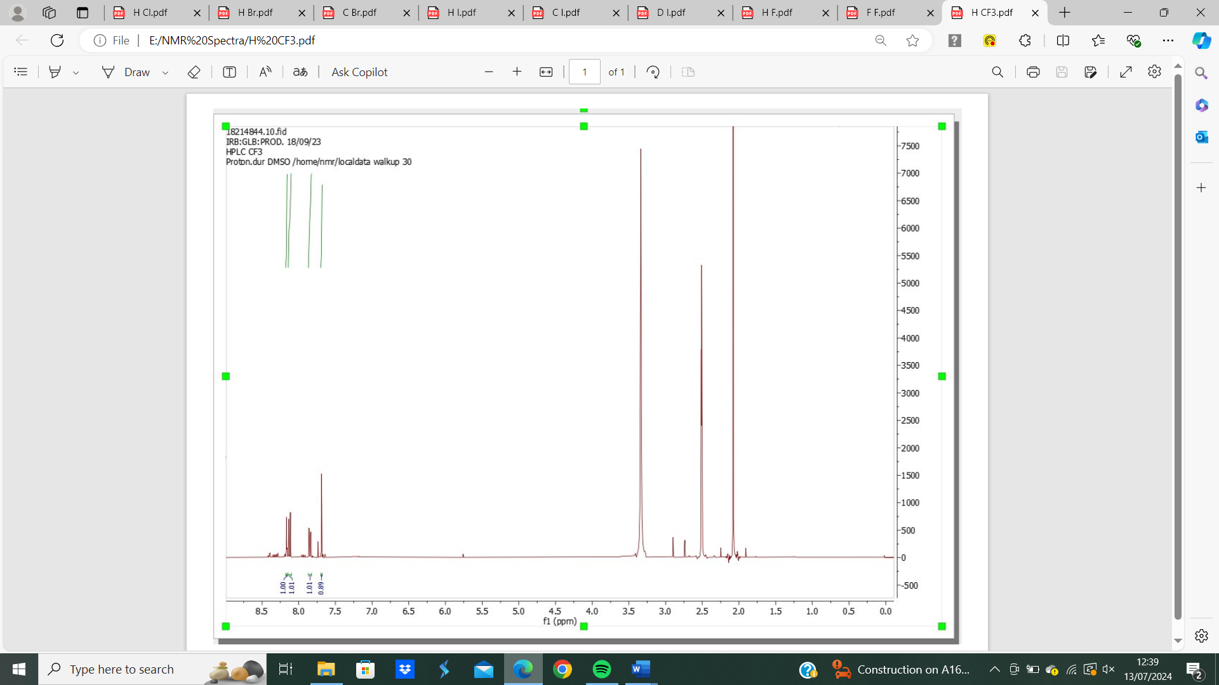
Figure 27: 2-(dichloromethyl)-1-nitro-4-(trifluoromethyl)benzene (121) ¹H NMR spectrum.

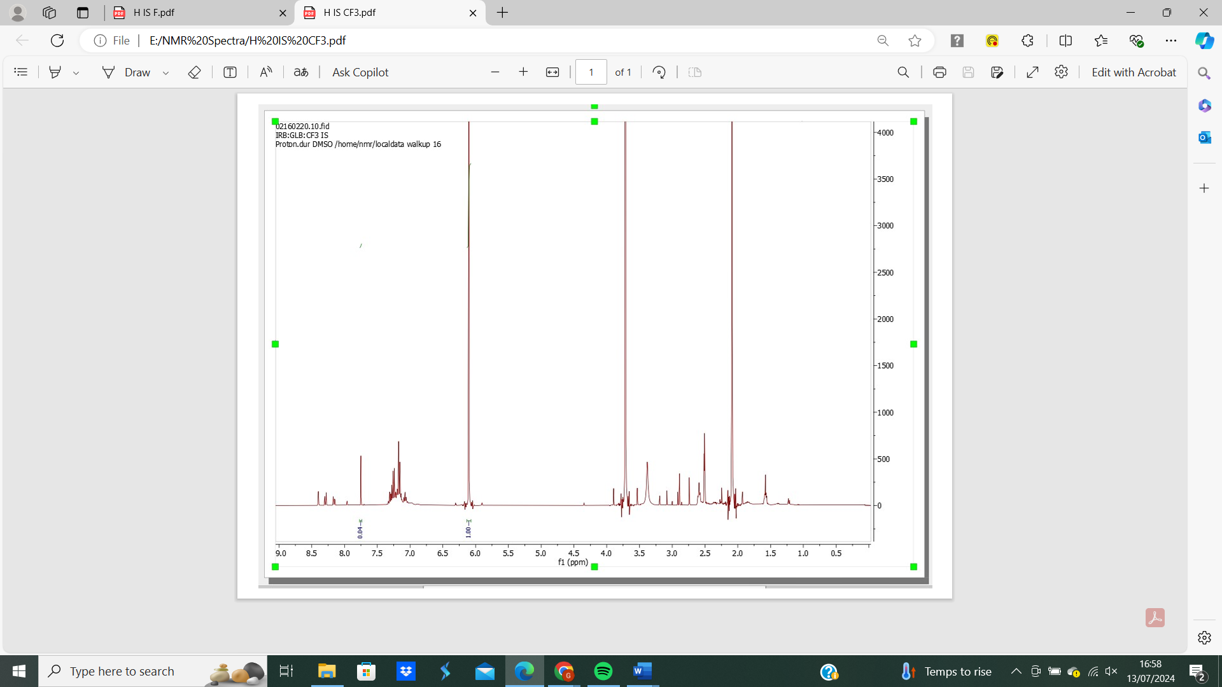
Figure 28: 2-(dichloromethyl)-1-nitro-4-(trifluoromethyl)benzene (121) ¹H NMR spectrum with internal standard.

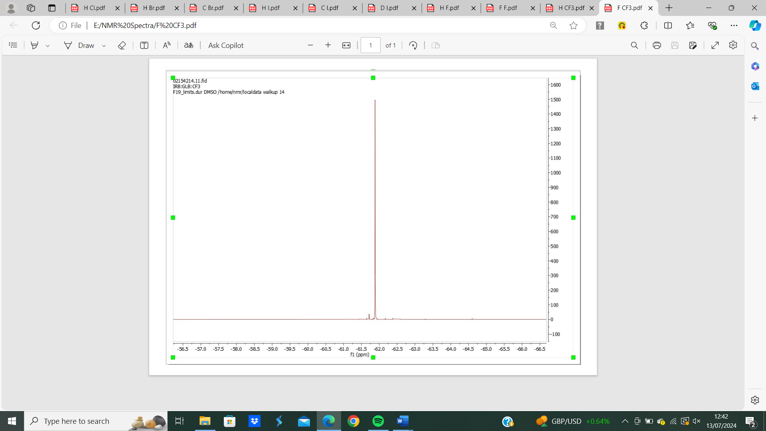
Figure 29: 2-(dichloromethyl)-1-nitro-4-(trifluoromethyl)benzene (121) ¹⁹F NMR spectrum.

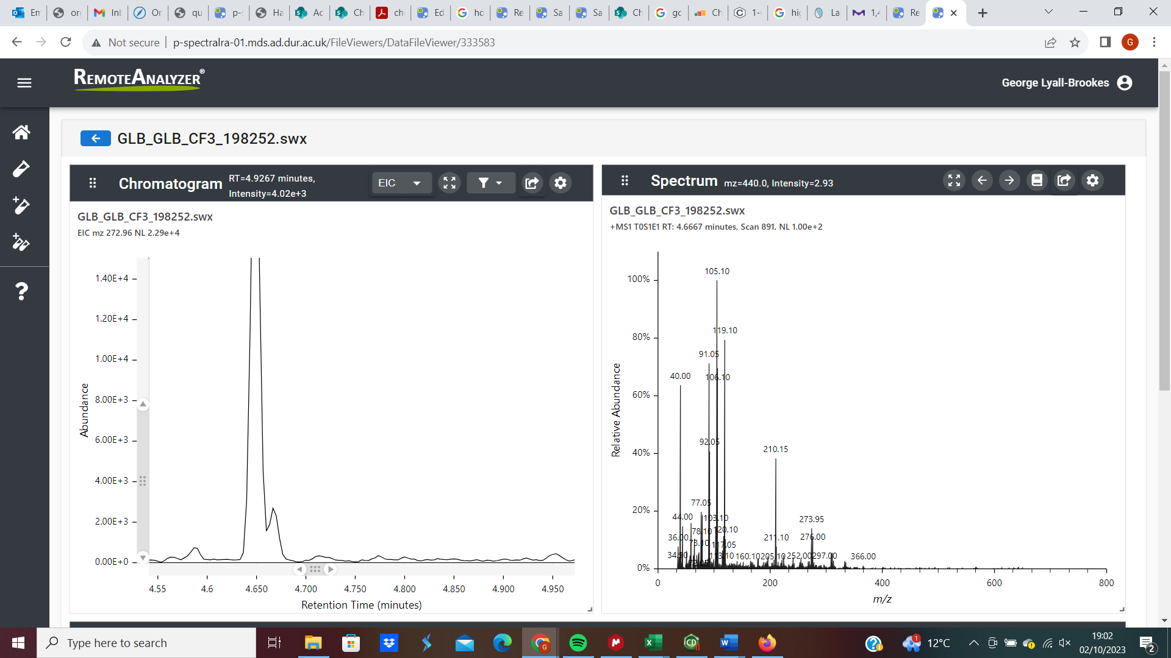
Figure 30: 2-(dichloromethyl)-1-nitro-4-(trifluoromethyl)benzene (121) GC-MS analysis.

2-(dichloromethyl)-1,4-dinitrobenzene (122)
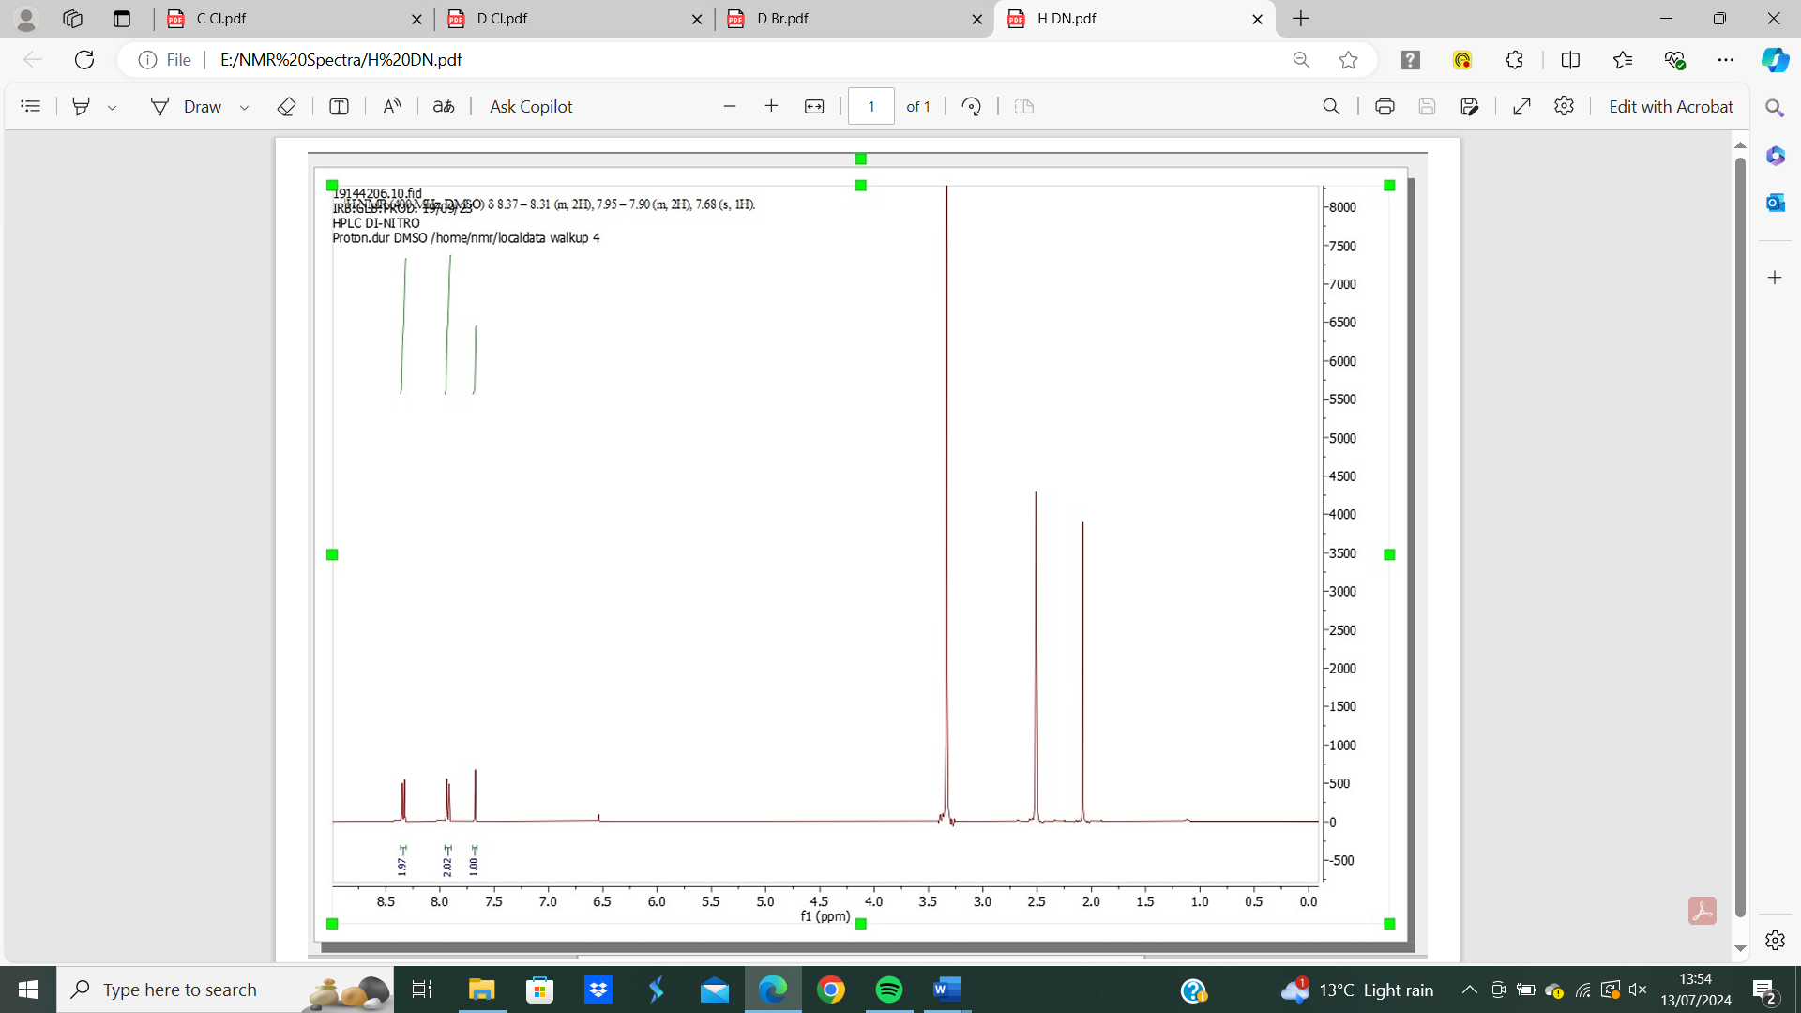
Figure 31: 2-(dichloromethyl)-1,4-dinitrobenzene (122) ¹H NMR spectrum.

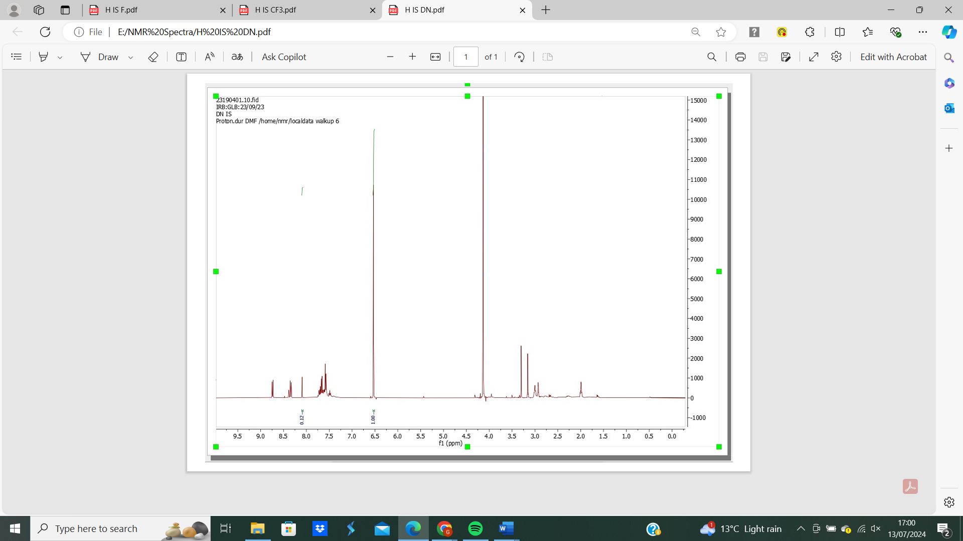
Figure 32: 2-(dichloromethyl)-1,4-dinitrobenzene (122) ¹H NMR spectrum with internal standard.

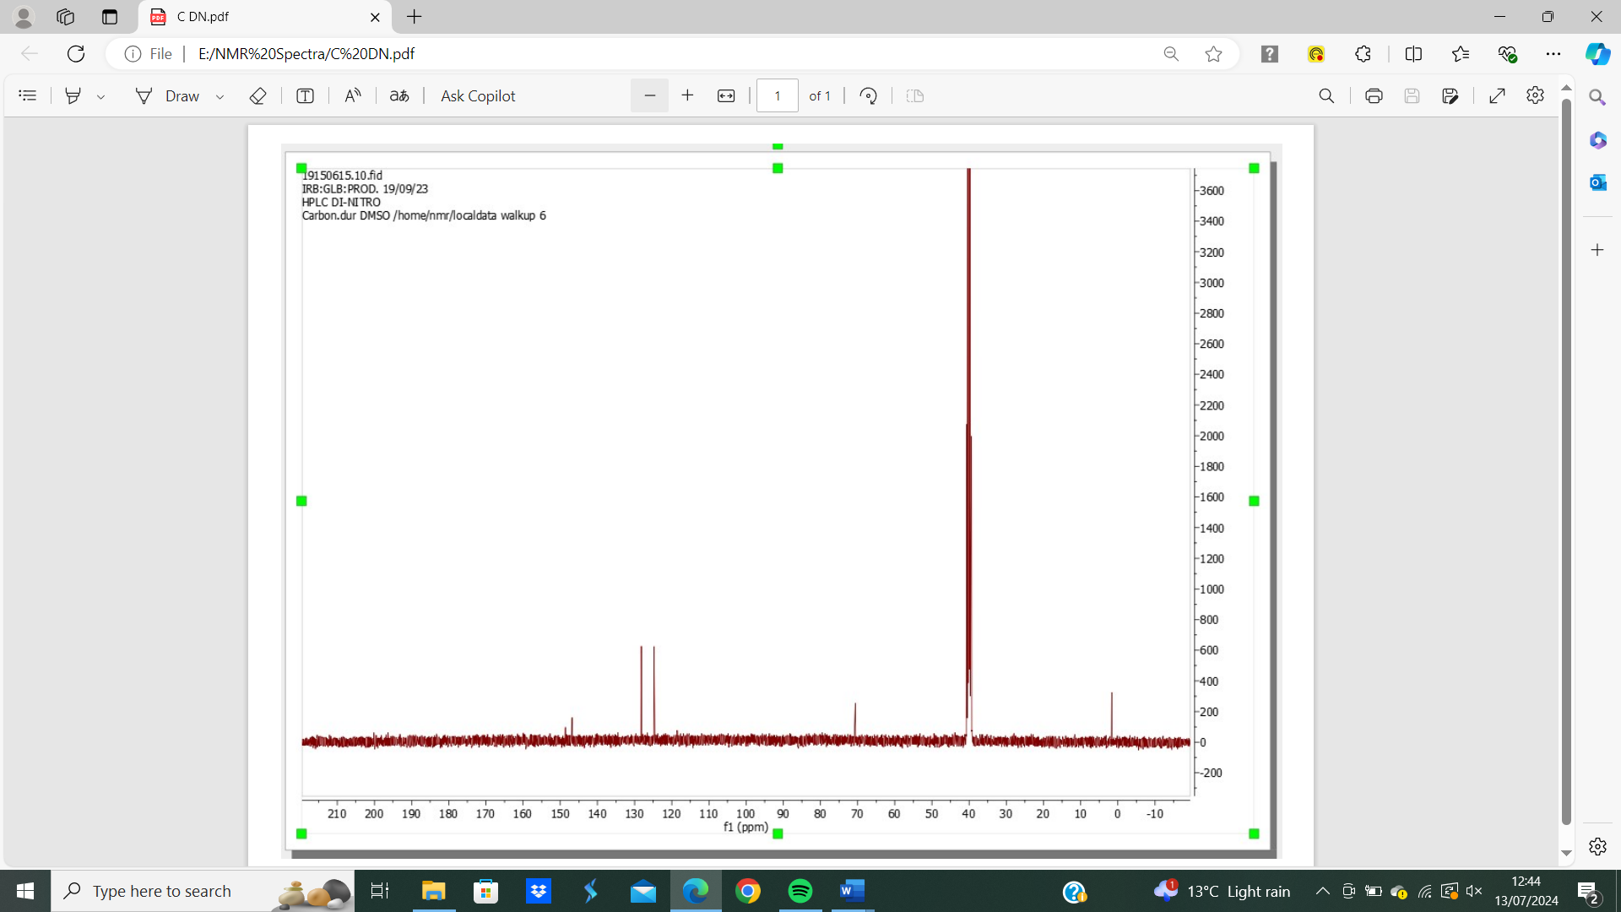
Figure 33: 2-(dichloromethyl)-1,4-dinitrobenzene (122) ¹³C NMR spectrum.

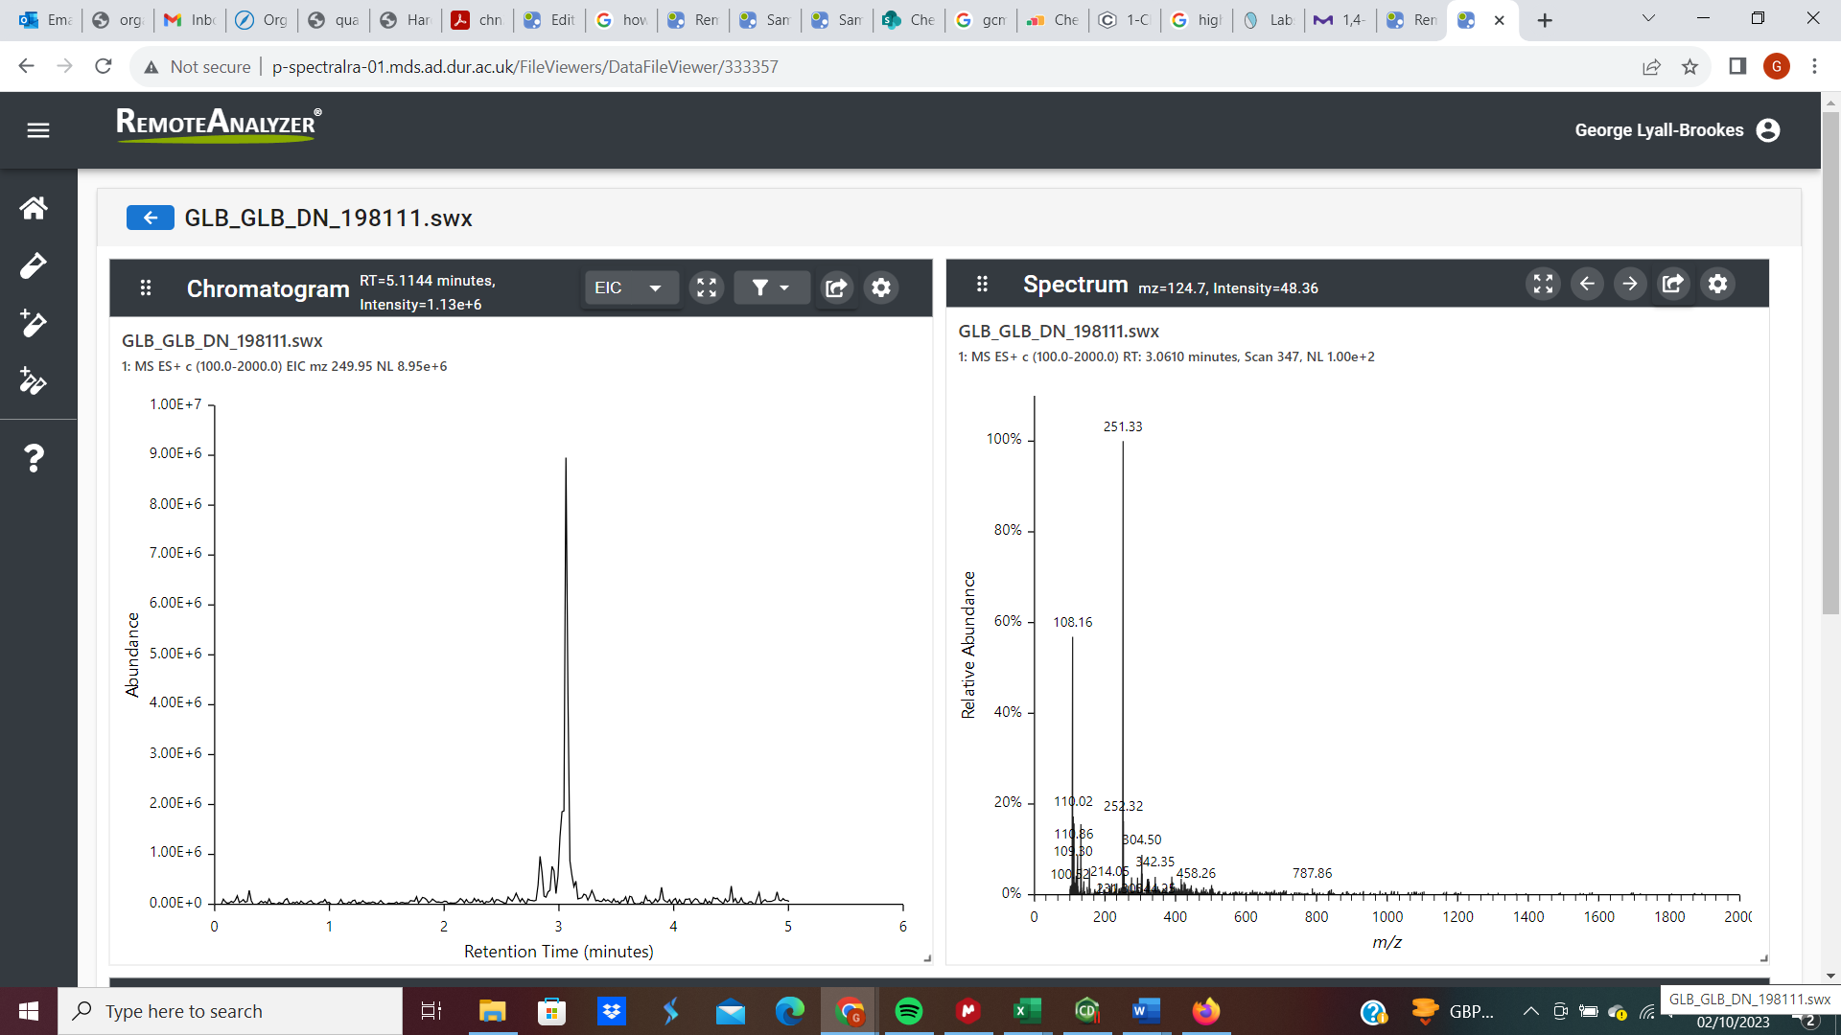
Figure 34: 2-(dichloromethyl)-1,4-dinitrobenzene (122) GC-MS analysis.

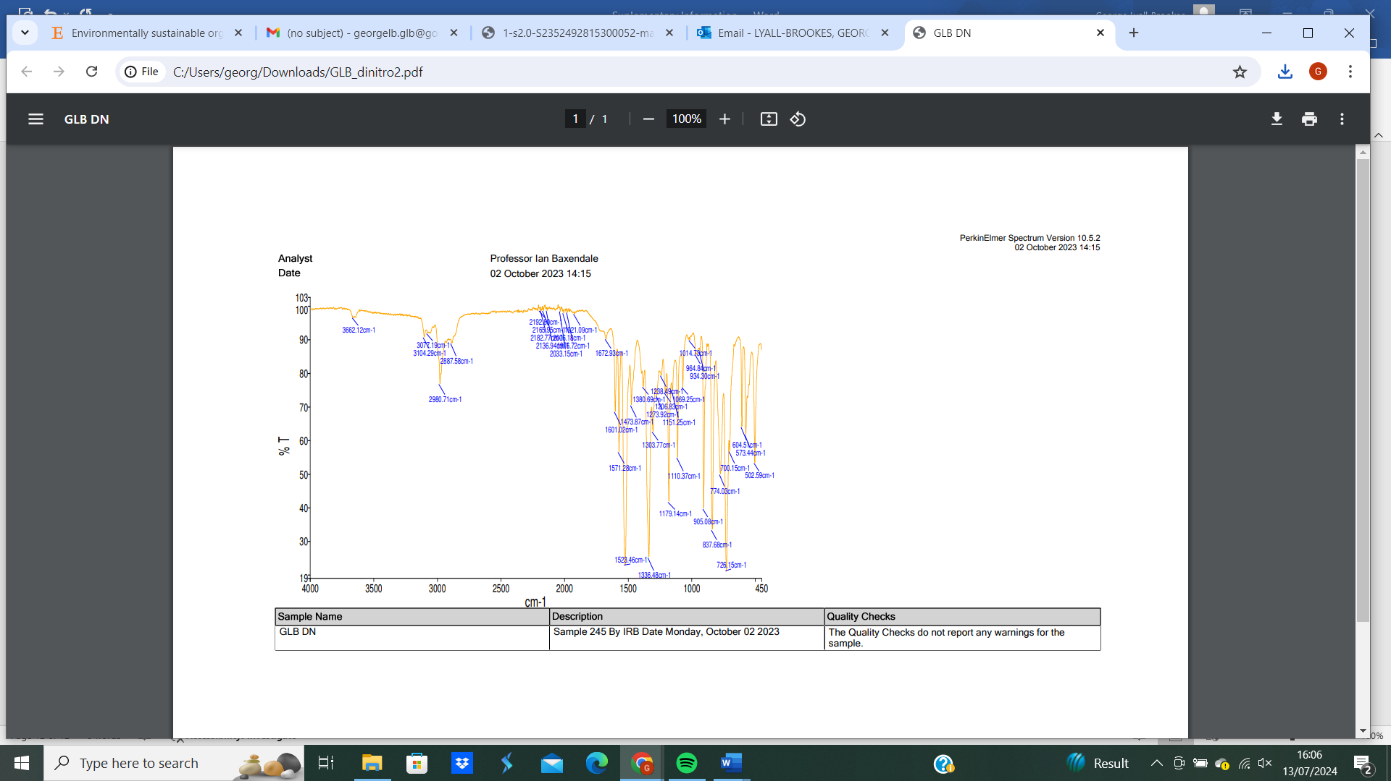
Figure 35: 2-(dichloromethyl)-1,4-dinitrobenzene (122) IR analysis.

1-(dichloromethyl)-2-nitrobenzene (116), 1-(dichloromethyl)-4-nitrobenzene (117)
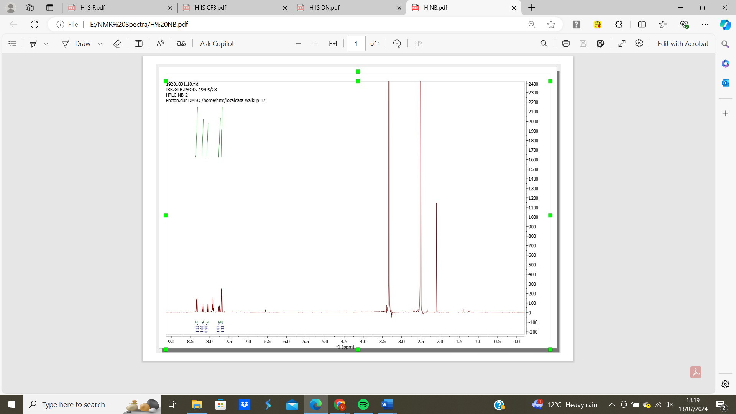
Figure 36: 1-(dichloromethyl)-2-nitrobenzene (116), 1-(dichloromethyl)-4-nitrobenzene (117) ¹H NMR spectrum.
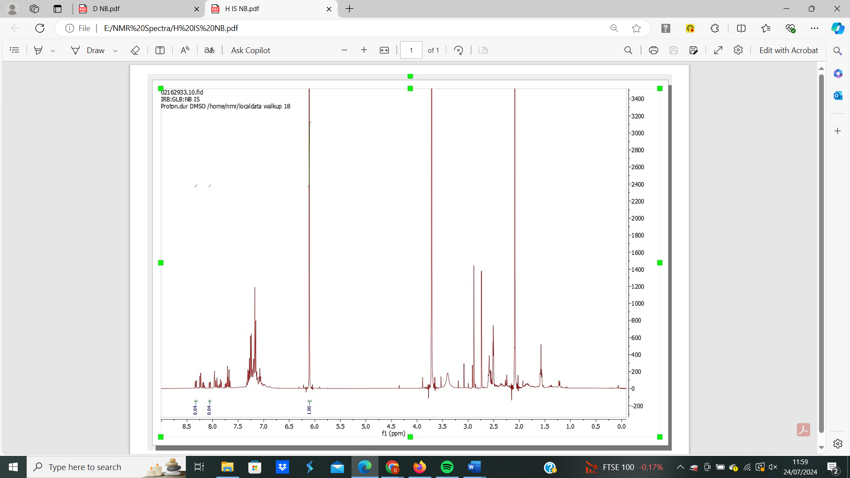
Figure 37: 1-(dichloromethyl)-2-nitrobenzene (116), 1-(dichloromethyl)-4-nitrobenzene (117) ¹H NMR spectrum with internal standard.

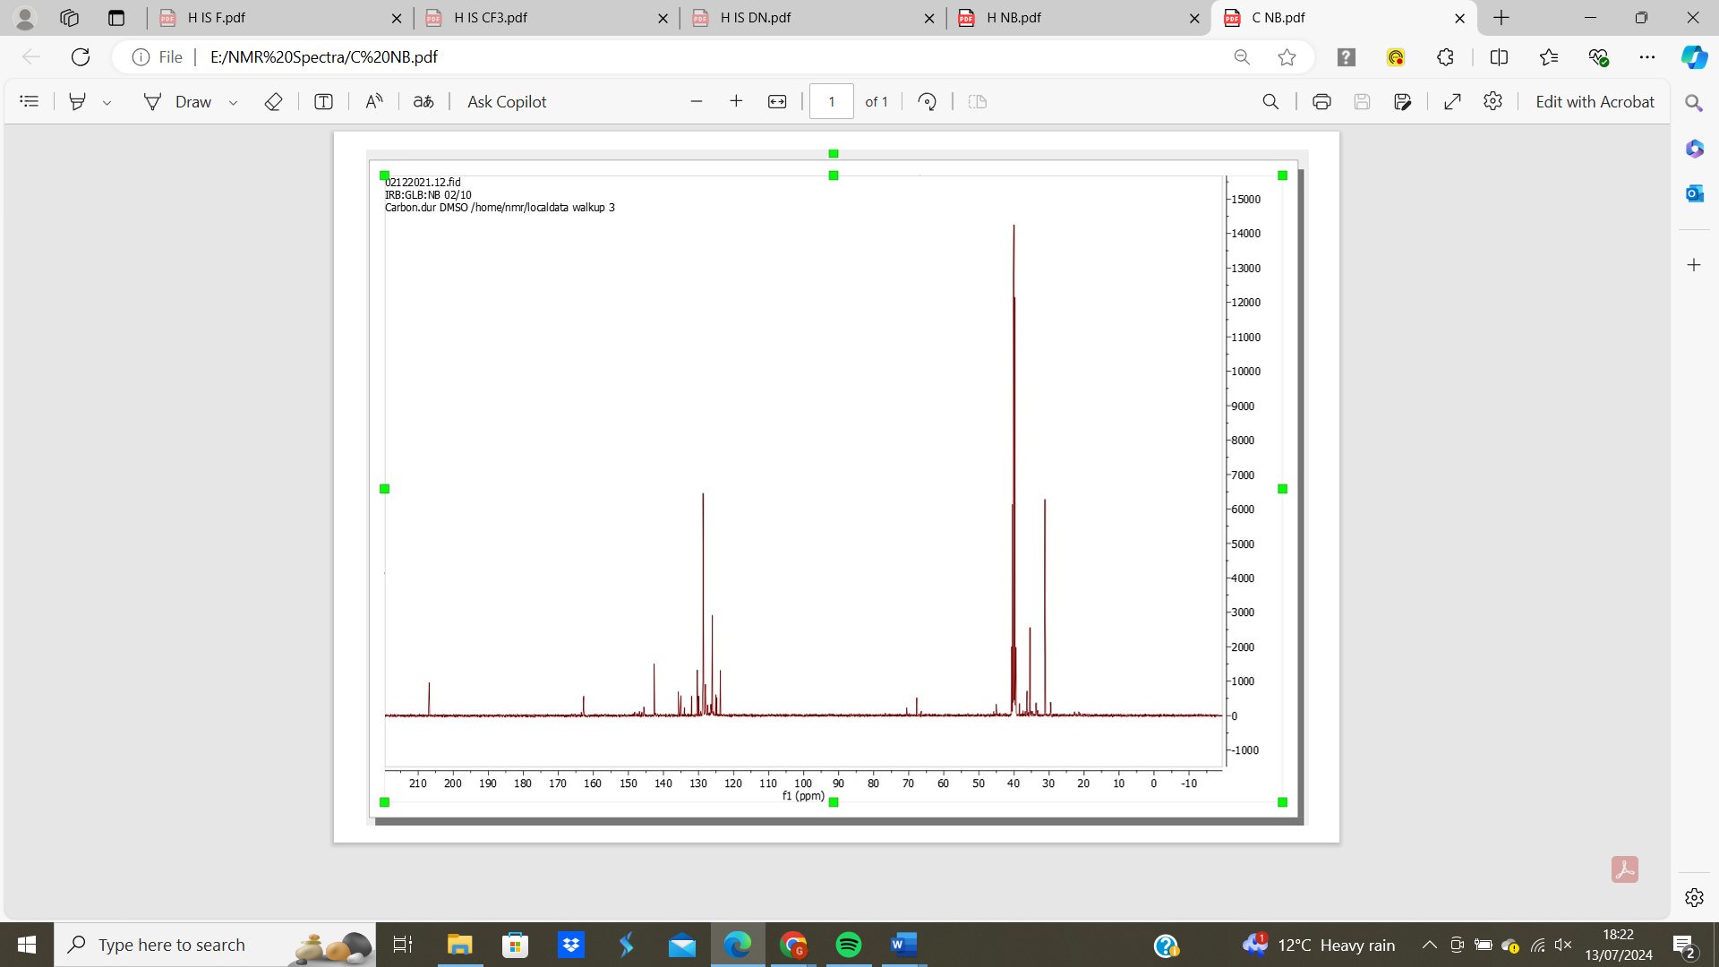
Figure 38: 1-(dichloromethyl)-2-nitrobenzene (116), 1-(dichloromethyl)-4-nitrobenzene (117) ¹³C NMR spectrum.
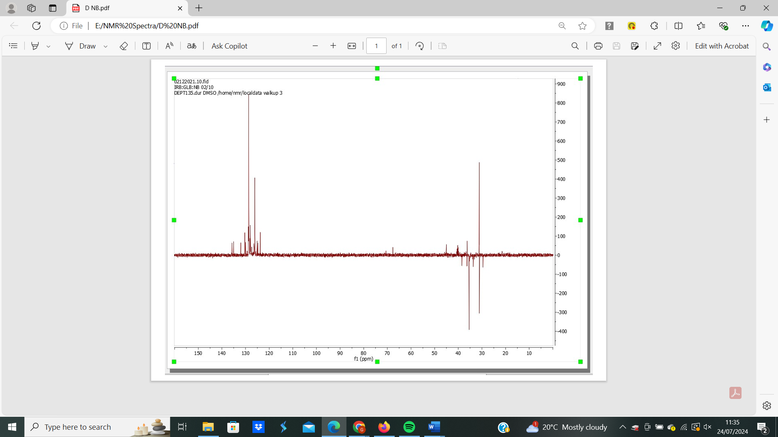
Figure 39: 1-(dichloromethyl)-2-nitrobenzene (116), 1-(dichloromethyl)-4-nitrobenzene (117) 13C DEPT spectrum.

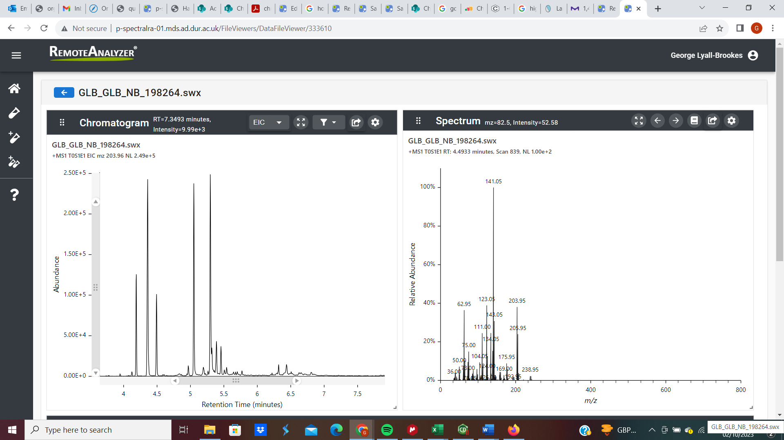
Figure 40: 1-(dichloromethyl)-2-nitrobenzene (116), 1-(dichloromethyl)-4-nitrobenzene (117) GC-MS analysis.

