How many seeds are there in a single raspberry?

Introduction
The results of chapters 5 & 6 in this research suggest Rubus ideaus is of significant value to the hunter-gatherer communities of the Mesolithic in Northwest Europe. Confirmed on 13 sites across 4 countries in the research area, with a number of other significant finds identified to Rubus spp. Or Rubus fruticosus/ideaus. There also appears to be several large deposits of R. ideaus and R. undifferentiated seeds; 78 at Tågerup (Regnell, 2011), 151 charred seeds at Llandevenny (Brown, 2005), and a very large deposit at Ronneholms Mosse (Regnell, 1998; Larsson & Sjöström, 2013).
During this research the author was unable to find any literature that would give an approximation of the number of seeds present in a single R. ideaus or any Rubus spp. Fruit. Whilst it is likely there is a range of seed quantities per fruit, particularly between differing years and thus differing conditions, in order to establish the number of fruit represented by these finds, an approximate/average value was required. Unlike drupes, berries and pomes that have a single seed or relatively few, aggregate fruits such as R. fruticosus and R. ideaus clearly have considerably more.
Without access to complete R. ideaus fruit macro-fossils from the period, it is impossible to infer whether fruits now have more or less seeds than their Mesolithic predecessors. It may be likely that modern fruits, with the help of cross-breeding with domesticated varieties, are larger and sweeter than the R. ideaus of the Mesolithic, but the same assumption cannot be safely made toward the number of seeds. It is not clear as to whether modern domesticated raspberries have more or less seeds than their wild counterparts, let alone Mesolithic raspberries.
In lieu of access to wild R. ideaus, an experiment was carried out to ascertain an average number of seeds per fruit in modern domesticated raspberries. The purpose of this experiment was to work as an indicator in order to suggest an approximate number of seeds per fruit and not to establish a hold-fast rule. A sample of 100 raspberries was used. The mass, volume and number of seeds was ascertained for each fruit as well as the dry mass of the seeds. The dry mass of the seeds was then divided by the number of seeds in the fruit in order to find the mass of a single seed.

Method
Each sample, a single raspberry, was weighed on a balance to ascertain the fruits mass. The fruit was then homogenised to remove any air trapped air and the material submerged in a known volume of water to find the fruit volume. This was only accurately measurable to 0.25 ml due to limitations with the equipment.
The sample was then washed through a graded sieve to extract the individual seeds. These were then air dried and counted. Once counted the seeds were weighed together to find the dry mass of all the seeds from a single fruit. A sum of the number of seeds divided by the mass of the total mass of seeds from a single fruit, was calculated in order to ascertain the mass of an individual seed for the completeness of this research. The results from this research are published in the table below.

Results
Sample | fruit mass (g) | fruit volume (ml to nearest 0.25) | Number of seeds | dry mass of seeds (g) | Mass of a seed (g) (mass of seeds/no. of seeds)
1 | 3.642 | 3.5 | 76 | 0.159 | 0.002092105
2 | 3.339 | 3.5 | 64 | 0.135 | 0.002109375
3 | 3.336 | 3.25 | 72 | 0.121 | 0.001680556
4 | 3.489 | 2.5 | 66 | 0.122 | 0.001848485
5 | 3.007 | 1.5 | 77 | 0.13 | 0.001688312
6 | 2.813 | 2 | 62 | 0.11 | 0.001774194
7 | 2.925 | 2.75 | 75 | 0.123 | 0.00164
8 | 4.595 | 3.75 | 86 | 0.176 | 0.002046512
9 | 3.702 | 2.75 | 65 | 0.129 | 0.001984615
10 | 3.936 | 3 | 69 | 0.127 | 0.00184058
11 | 2.92 | 2 | 59 | 0.099 | 0.001677966
12 | 1.968 | 1.25 | 72 | 0.092 | 0.001277778
13 | 2.814 | 2.25 | 61 | 0.095 | 0.001557377
14 | 2.603 | 2.5 | 62 | 0.106 | 0.001709677
15 | 1.822 | 1.75 | 60 | 0.089 | 0.001483333
16 | 2.091 | 1.75 | 44 | 0.075 | 0.001704545
17 | 2.839 | 1.5 | 69 | 0.118 | 0.001710145
18 | 2.888 | 2 | 82 | 0.13 | 0.001585366
19 | 2.532 | 2.5 | 55 | 0.109 | 0.001981818
20 | 3.343 | 2 | 85 | 0.152 | 0.001788235
21 | 2.526 | 3 | 66 | 0.124 | 0.001878788
22 | 3.292 | 2 | 59 | 0.117 | 0.001983051
23 | 3.349 | 2.5 | 74 | 0.135 | 0.001824324
24 | 2.393 | 2 | 59 | 0.111 | 0.001881356
25 | 2.856 | 2.5 | 78 | 0.123 | 0.001576923
26 | 1.859 | 1.25 | 57 | 0.078 | 0.001368421
27 | 2.618 | 2.25 | 67 | 0.124 | 0.001850746
28 | 2.828 | 2 | 60 | 0.112 | 0.001866667
29 | 2.343 | 2 | 68 | 0.115 | 0.001691176
30 | 2.714 | 2.5 | 82 | 0.13 | 0.001585366
31 | 2.63 | 2 | 56 | 0.107 | 0.001910714
32 | 2.81 | 2.5 | 64 | 0.11 | 0.00171875
33 | 3.127 | 3 | 72 | 0.138 | 0.001916667
34 | 3.186 | 2.75 | 67 | 0.121 | 0.00180597
35 | 3.636 | 1.75 | 86 | 0.149 | 0.001732558
36 | 2.449 | 2 | 50 | 0.091 | 0.00182
37 | 2.628 | 2 | 71 | 0.143 | 0.002014085
38 | 3.667 | 3.25 | 78 | 0.161 | 0.002064103
39 | 2.414 | 2.5 | 69 | 0.126 | 0.001826087
40 | 2.541 | 2.25 | 62 | 0.102 | 0.001645161
41 | 2.459 | 2 | 75 | 0.1 | 0.001333333
42 | 3.129 | 3 | 72 | 0.127 | 0.001763889
43 | 1.783 | 2 | 57 | 0.092 | 0.001614035
44 | 1.814 | 1.5 | 58 | 0.098 | 0.001689655
45 | 1.725 | 1.5 | 62 | 0.103 | 0.00166129
46 | 1.483 | 1.25 | 65 | 0.092 | 0.001415385
47 | 3.503 | 3 | 86 | 0.121 | 0.001406977
48 | 1.144 | 1.25 | 30 | 0.05 | 0.001666667
49 | 5.247 | 5.25 | 61 | 0.15 | 0.002459016
50 | 3.539 | 3.25 | 70 | 0.146 | 0.002085714
51 | 2.532 | 2.25 | 55 | 0.102 | 0.001854545
52 | 3.234 | 3 | 66 | 0.112 | 0.00169697
53 | 2.494 | 2.5 | 66 | 0.108 | 0.001636364
54 | 2.522 | 2.5 | 67 | 0.121 | 0.00180597
55 | 2.637 | 2.5 | 71 | 0.103 | 0.001450704
56 | 3.264 | 3 | 72 | 0.133 | 0.001847222
57 | 2.449 | 2.25 | 83 | 0.115 | 0.001385542
58 | 1.305 | 1 | 66 | 0.085 | 0.001287879
59 | 1.524 | 1.5 | 36 | 0.077 | 0.002138889
60 | 2.668 | 2.5 | 68 | 0.126 | 0.001852941
61 | 2.181 | 2.25 | 51 | 0.073 | 0.001431373
62 | 1.881 | 1.5 | 58 | 0.101 | 0.001741379
63 | 1.625 | 1.5 | 65 | 0.101 | 0.001553846
64 | 2.323 | 2 | 64 | 0.101 | 0.001578125
65 | 2.57 | 2.5 | 75 | 0.126 | 0.00168
66 | 1.84 | 1.75 | 67 | 0.123 | 0.001835821
67 | 2.435 | 2.25 | 69 | 0.126 | 0.001826087
68 | 1.399 | 1.5 | 35 | 0.051 | 0.001457143
69 | 1.545 | 2 | 51 | 0.067 | 0.001313725
70 | 1.294 | 1 | 46 | 0.077 | 0.001673913
71 | 2.106 | 2.25 | 75 | 0.12 | 0.0016
72 | 1.669 | 1.75 | 74 | 0.075 | 0.001013514
73 | 1.868 | 1.75 | 83 | 0.086 | 0.001036145
74 | 2.32 | 2.5 | 76 | 0.117 | 0.001539474
75 | 0.846 | 0.75 | 50 | 0.056 | 0.00112
76 | 1.782 | 1.75 | 51 | 0.081 | 0.001588235
77 | 2.007 | 2.25 | 95 | 0.138 | 0.001452632
78 | 1.727 | 1.75 | 54 | 0.095 | 0.001759259
79 | 1.696 | 1.75 | 74 | 0.084 | 0.001135135
80 | 2.148 | 2 | 73 | 0.108 | 0.001479452
81 | 1.784 | 1.75 | 68 | 0.089 | 0.001308824
82 | 1.856 | 1.75 | 57 | 0.09 | 0.001578947
83 | 1.858 | 1.75 | 60 | 0.092 | 0.001533333
84 | 1.676 | 1.75 | 64 | 0.079 | 0.001234375
85 | 2.144 | 2.5 | 51 | 0.082 | 0.001607843
86 | 1.312 | 1.5 | 44 | 0.071 | 0.001613636
87 | 1.986 | 2 | 54 | 0.105 | 0.001944444
88 | 1.761 | 1.5 | 49 | 0.078 | 0.001591837
89 | 1.971 | 1.75 | 71 | 0.12 | 0.001690141
90 | 1.929 | 2 | 70 | 0.105 | 0.0015
91 | 1.787 | 1.75 | 58 | 0.101 | 0.001741379
92 | 2.053 | 2.25 | 50 | 0.084 | 0.00168
93 | 2.094 | 2.25 | 62 | 0.113 | 0.001822581
94 | 2.303 | 2.5 | 61 | 0.107 | 0.001754098
95 | 1.595 | 2 | 66 | 0.098 | 0.001484848
96 | 2.144 | 2 | 65 | 0.109 | 0.001676923
97 | 1.494 | 1.5 | 69 | 0.096 | 0.001391304
98 | 2.096 | 2.5 | 75 | 0.123 | 0.00164
99 | 1.812 | 1.75 | 71 | 0.124 | 0.001746479
100 | 1.747 | 1.75 | 63 | 0.125 | 0.001984127
 | fruit mass (g) | fruit volume (ml to nearest 0.25) | Number of seeds | dry mass of seeds (g) | Mass of a seed (g) (mass of seeds/no. of seeds)
Total: | 241.589 | 216.25 | 6506 | 10.872 | 0.167535253
Mean: | 2.416 | 2.163 | 65.060 | 0.109 | 0.002
Table 1: Results of raspberry experiment including: fruit mass, fruit volume, number of seeds, mass of seeds and mass of individual seed.

Discussion
Average number of seeds of a domesticated raspberry is 65. Assuming a potential range of 50% either side of the average modern raspberry for the archaic Mesolithic wild raspberry, the number of seeds range would be 33-130 seeds per fruit. Using the average number of seeds from a domesticated fruit, 151 seeds as was found at Llandevenny (Brown, 2005), pertains to 5 ml (to nearest 0.25 ml) of fruit volume. Using the aforementioned range, this could represent 10 ml – 2.5 ml of fruit.
The range of seeds per fruit would imply that, what appears to be a large accumulation of seeds, like the site of Llandevenny, would actually only represent 1-5 raspberries. Should an excavation yield a find of 1000 seeds, this would still only represent 8-30 fruits with a range of 16.5 - 66.5 ml of fruit volume. A relatively large yield of 500 raspberries from a single harvesting event, 1.25 - 5 litres fruit volume, if deposited together and all of the seeds persist in the archaeological record, would be a find of 16,500 – 65,000 seeds. It is therefore likely that excavation on a site where a raspberry or blackberry bush grew would yield many thousands if not millions of seeds and would therefore be a visible and significant find.
The mass of the dry seeds is on average 1/24th of the mass of the whole raspberry. This small mass, coupled with the anecdotal evidence of difficulties experienced by the author in extracting the seeds from the fruit during this experiment, suggests that the majority of seeds may be consumed rather than discarded on a site as a result of processing techniques. Mesolithic coprolites would need to be examined in order to ascertain whether seeds are being consumed as a whole fruit or whether processed seeds are dumped away from sites.

Conclusion
The experiment has identified that due to the large number of seeds per fruit, a range of 33-130, the seed finds recovered during excavation likely represent very few actual whole fruit. This suggest most raspberry seeds are likely being consumed with the fruit as a whole, and would thus be found in coprolites away from site. This would also suggest the finds we do have are not hoards or deposits of large scale processing debitage, but instead represent the few fruit that may have been accidentally dropped and lost or squashed on the floor, perhaps also falling in the fire during cooking and becoming charred, or even rejected by the consumer as unpalatable.
The finds are unlikely to represent natural deposition from tree-fall fruits accumulating around the plant. Within the lifespan of a Rubus spp. plant, it may create a deposit of millions of seeds, which would surely be significant and noticeable in the record. It should be noted however, that due to the very small size and mass of the seeds, they may not persist in the archaeological record. The seeds we do find may be a small number that have persisted and that do in fact represent a larger number.

Evaluation
This experiment is limited by the possible discrepancies between the number of seeds and fruit volume in archaic wild raspberries, modern wild raspberries and modern domesticated raspberries. A range has been used of 50% to compensate for this possible variation, however without examining whole archaic raspberries, finding an average number of seeds seems unlikely. A larger sample size is also required to create a testable set of results.
A similar and perhaps more accurate experiment could be carried out with wild Rubus fruitcosus on account of the large number of readily available wild specimens. However, as an aggregate species there is likely a large variation in the number of seeds and it is still limited by a lack of access to archaic R. fruticosus. Similarly, being an aggregate species, it may have also readily inter-bred with domesticated fruits in recent history, which may impact the number of seeds and volume of the fruits.
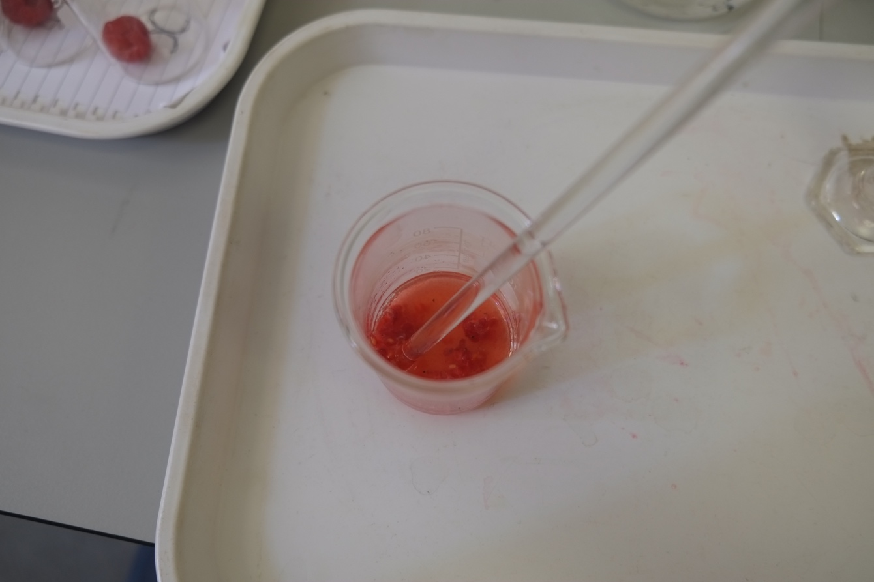
Figure 1 Homogenised Raspberry - Source: Author 09/04/2015
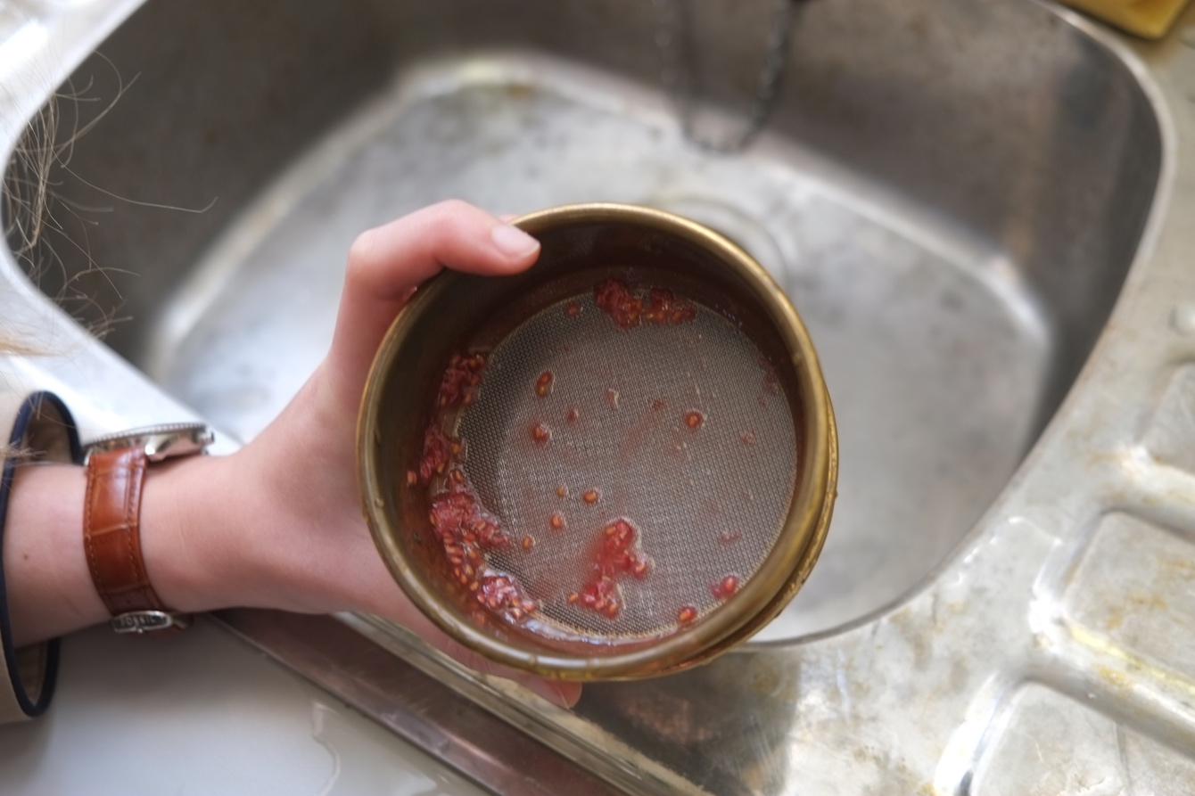
Figure 2 Extracting seeds from raspberry - Source: Author 09/04/2015
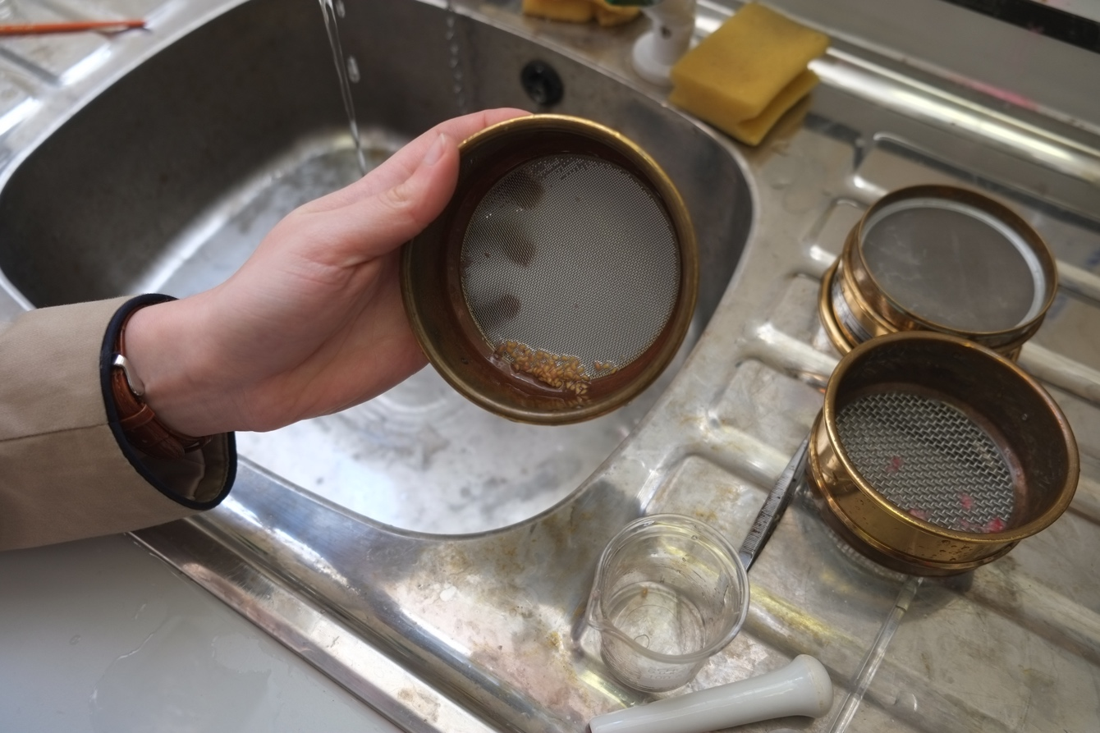
Figure 3 Seeds extracted from raspberry fruit Source: Author 09/04/2016

